Hospital Management System – Database Testing Project
Introduction | About Project | Page 01
Step 01 | Database creation | Starting Page 01
Step 02 | Table creation | Starting Page 01
Step 03 | Data Insertion into Table | Starting Page 22
Step 04 | ER Diagram | Page 65
Step 05 | Database Verification and Testing | Starting Page 66
Introduction:
A MySQL-based Hospital Management System Database Testing project designed to validate the accuracy, integrity, consistency, and reliability of hospital and website-related data. The database includes modules for patients, doctors, appointments, medical records, prescriptions, medicines, admissions, billing, payments, website content, feedback, and notifications.
The project focuses on testing CRUD operations, Primary/Foreign Keys, constraints, duplicate data, JOIN queries, aggregate functions, GROUP BY/HAVING, data consistency, boundary values, billing and payment validation, orphan records, and real-world business rules using SQL.
Step 01:
Database Creation:
CREATE DATABASE hospital_management_system;
USE hospital_management_system;
Step 02:
Table Creation:
MODULE 01: USER & PATIENT MANAGEMENT
TABLE 01: user_roles
CREATE TABLE user_roles (
role_id INT AUTO_INCREMENT PRIMARY KEY,
role_name VARCHAR(50) NOT NULL UNIQUE,
description VARCHAR(255),
status VARCHAR(20) NOT NULL DEFAULT 'Active',
CONSTRAINT chk_user_roles_status
CHECK (status IN ('Active', 'Inactive'))
);
TABLE 02: users
CREATE TABLE users (
user_id INT AUTO_INCREMENT PRIMARY KEY,
role_id INT NOT NULL,
username VARCHAR(50) NOT NULL UNIQUE,
email VARCHAR(100) NOT NULL UNIQUE,
password_hash VARCHAR(255) NOT NULL,
first_name VARCHAR(50) NOT NULL,
last_name VARCHAR(50) NOT NULL,
phone VARCHAR(20),
status VARCHAR(20) NOT NULL DEFAULT 'Active',
last_login DATETIME,
created_at DATETIME NOT NULL DEFAULT CURRENT_TIMESTAMP,
CONSTRAINT fk_users_role
FOREIGN KEY (role_id)
REFERENCES user_roles(role_id)
ON UPDATE CASCADE
ON DELETE RESTRICT,
CONSTRAINT chk_users_status
CHECK (status IN ('Active', 'Inactive', 'Blocked'))
);
TABLE 03: patients
CREATE TABLE patients (
patient_id INT AUTO_INCREMENT PRIMARY KEY,
user_id INT NOT NULL,
date_of_birth DATE NOT NULL,
gender VARCHAR(20) NOT NULL,
blood_group VARCHAR(5),
address VARCHAR(255),
emergency_contact_name VARCHAR(100),
emergency_contact_phone VARCHAR(20),
insurance_number VARCHAR(50) UNIQUE,
created_at DATETIME NOT NULL DEFAULT CURRENT_TIMESTAMP,
CONSTRAINT fk_patients_user
FOREIGN KEY (user_id)
REFERENCES users(user_id)
ON UPDATE CASCADE
ON DELETE RESTRICT,
CONSTRAINT chk_patients_gender
CHECK (gender IN ('Male', 'Female', 'Other')),
CONSTRAINT chk_patients_blood_group
CHECK (
blood_group IS NULL OR
blood_group IN (
'A+', 'A-', 'B+', 'B-',
'AB+', 'AB-', 'O+', 'O-'
)
)
);
MODULE 02: HOSPITAL MANAGEMENT
TABLE 04: departments
CREATE TABLE departments (
department_id INT AUTO_INCREMENT PRIMARY KEY,
department_name VARCHAR(100) NOT NULL UNIQUE,
description TEXT,
location VARCHAR(100),
phone VARCHAR(20),
status VARCHAR(20) NOT NULL DEFAULT 'Active',
CONSTRAINT chk_departments_status
CHECK (status IN ('Active', 'Inactive'))
);
TABLE 05: doctors
CREATE TABLE doctors (
doctor_id INT AUTO_INCREMENT PRIMARY KEY,
user_id INT NOT NULL,
department_id INT NOT NULL,
specialization VARCHAR(100) NOT NULL,
license_number VARCHAR(50) NOT NULL UNIQUE,
qualification VARCHAR(150),
joining_date DATE,
consultation_fee DECIMAL(10,2) NOT NULL DEFAULT 0.00,
status VARCHAR(20) NOT NULL DEFAULT 'Active',
CONSTRAINT fk_doctors_user
FOREIGN KEY (user_id)
REFERENCES users(user_id)
ON UPDATE CASCADE
ON DELETE RESTRICT,
CONSTRAINT fk_doctors_department
FOREIGN KEY (department_id)
REFERENCES departments(department_id)
ON UPDATE CASCADE
ON DELETE RESTRICT,
CONSTRAINT chk_doctors_fee
CHECK (consultation_fee >= 0),
CONSTRAINT chk_doctors_status
CHECK (status IN ('Active', 'Inactive', 'On Leave'))
);
TABLE 06: rooms
CREATE TABLE rooms (
room_id INT AUTO_INCREMENT PRIMARY KEY,
room_number VARCHAR(20) NOT NULL UNIQUE,
room_type VARCHAR(50) NOT NULL,
floor_number INT NOT NULL,
bed_count INT NOT NULL,
available_beds INT NOT NULL,
daily_rate DECIMAL(10,2) NOT NULL DEFAULT 0.00,
status VARCHAR(20) NOT NULL DEFAULT 'Available',
CONSTRAINT chk_rooms_floor
CHECK (floor_number >= 0),
CONSTRAINT chk_rooms_bed_count
CHECK (bed_count > 0),
CONSTRAINT chk_rooms_available_beds
CHECK (
available_beds >= 0
AND available_beds <= bed_count
),
CONSTRAINT chk_rooms_rate
CHECK (daily_rate >= 0),
CONSTRAINT chk_rooms_status
CHECK (
status IN (
'Available',
'Occupied',
'Maintenance',
'Inactive'
)
)
);
TABLE 07: admissions
CREATE TABLE admissions (
admission_id INT AUTO_INCREMENT PRIMARY KEY,
patient_id INT NOT NULL,
doctor_id INT NOT NULL,
room_id INT NOT NULL,
admission_date DATETIME NOT NULL DEFAULT CURRENT_TIMESTAMP,
discharge_date DATETIME,
admission_reason VARCHAR(255),
status VARCHAR(20) NOT NULL DEFAULT 'Admitted',
CONSTRAINT fk_admissions_patient
FOREIGN KEY (patient_id)
REFERENCES patients(patient_id)
ON UPDATE CASCADE
ON DELETE RESTRICT,
CONSTRAINT fk_admissions_doctor
FOREIGN KEY (doctor_id)
REFERENCES doctors(doctor_id)
ON UPDATE CASCADE
ON DELETE RESTRICT,
CONSTRAINT fk_admissions_room
FOREIGN KEY (room_id)
REFERENCES rooms(room_id)
ON UPDATE CASCADE
ON DELETE RESTRICT,
CONSTRAINT chk_admissions_dates
CHECK (
discharge_date IS NULL
OR discharge_date >= admission_date
),
CONSTRAINT chk_admissions_status
CHECK (
status IN (
'Admitted',
'Discharged',
'Transferred',
'Cancelled'
)
)
);
MODULE 03: APPOINTMENT & MEDICAL MANAGEMENT
TABLE 08: services
CREATE TABLE services (
service_id INT AUTO_INCREMENT PRIMARY KEY,
department_id INT NOT NULL,
service_name VARCHAR(100) NOT NULL UNIQUE,
description TEXT,
service_fee DECIMAL(10,2) NOT NULL DEFAULT 0.00,
duration_minutes INT,
status VARCHAR(20) NOT NULL DEFAULT 'Active',
created_at DATETIME NOT NULL DEFAULT CURRENT_TIMESTAMP,
CONSTRAINT fk_services_department
FOREIGN KEY (department_id)
REFERENCES departments(department_id)
ON UPDATE CASCADE
ON DELETE RESTRICT,
CONSTRAINT chk_services_fee
CHECK (service_fee >= 0),
CONSTRAINT chk_services_duration
CHECK (
duration_minutes IS NULL
OR duration_minutes > 0
),
CONSTRAINT chk_services_status
CHECK (status IN ('Active', 'Inactive'))
);
TABLE 09: appointments
CREATE TABLE appointments (
appointment_id INT AUTO_INCREMENT PRIMARY KEY,
patient_id INT NOT NULL,
doctor_id INT NOT NULL,
service_id INT NOT NULL,
appointment_date DATE NOT NULL,
appointment_time TIME NOT NULL,
appointment_type VARCHAR(50) NOT NULL DEFAULT 'In-Person',
reason VARCHAR(255),
status VARCHAR(20) NOT NULL DEFAULT 'Scheduled',
created_at DATETIME NOT NULL DEFAULT CURRENT_TIMESTAMP,

CONSTRAINT fk_appointments_patient
FOREIGN KEY (patient_id)
REFERENCES patients(patient_id)
ON UPDATE CASCADE
ON DELETE RESTRICT,
CONSTRAINT fk_appointments_doctor
FOREIGN KEY (doctor_id)
REFERENCES doctors(doctor_id)
ON UPDATE CASCADE
ON DELETE RESTRICT,
CONSTRAINT fk_appointments_service
FOREIGN KEY (service_id)
REFERENCES services(service_id)
ON UPDATE CASCADE
ON DELETE RESTRICT,
CONSTRAINT chk_appointments_type
CHECK (
appointment_type IN (
'In-Person',
'Online',
'Emergency',
'Follow-Up'
)
),
CONSTRAINT chk_appointments_status
CHECK (
status IN (
'Scheduled',
'Confirmed',
'Completed',
'Cancelled',
'No Show'
)
)
);
TABLE 10: medical_records
CREATE TABLE medical_records (
record_id INT AUTO_INCREMENT PRIMARY KEY,
patient_id INT NOT NULL,
doctor_id INT NOT NULL,
appointment_id INT,
diagnosis VARCHAR(255),
symptoms TEXT,
treatment TEXT,
notes TEXT,
record_date DATETIME NOT NULL DEFAULT CURRENT_TIMESTAMP,
CONSTRAINT fk_medical_records_patient
FOREIGN KEY (patient_id)
REFERENCES patients(patient_id)
ON UPDATE CASCADE
ON DELETE RESTRICT,
CONSTRAINT fk_medical_records_doctor
FOREIGN KEY (doctor_id)
REFERENCES doctors(doctor_id)
ON UPDATE CASCADE
ON DELETE RESTRICT,
CONSTRAINT fk_medical_records_appointment
FOREIGN KEY (appointment_id)
REFERENCES appointments(appointment_id)
ON UPDATE CASCADE
ON DELETE SET NULL
);
TABLE 11: prescriptions
CREATE TABLE prescriptions (
prescription_id INT AUTO_INCREMENT PRIMARY KEY,
patient_id INT NOT NULL,
doctor_id INT NOT NULL,
record_id INT NOT NULL,
prescription_date DATE NOT NULL DEFAULT (CURRENT_DATE),
instructions TEXT,
status VARCHAR(20) NOT NULL DEFAULT 'Active',
CONSTRAINT fk_prescriptions_patient
FOREIGN KEY (patient_id)
REFERENCES patients(patient_id)
ON UPDATE CASCADE
ON DELETE RESTRICT,
CONSTRAINT fk_prescriptions_doctor
FOREIGN KEY (doctor_id)
REFERENCES doctors(doctor_id)
ON UPDATE CASCADE
ON DELETE RESTRICT,
CONSTRAINT fk_prescriptions_record
FOREIGN KEY (record_id)
REFERENCES medical_records(record_id)
ON UPDATE CASCADE
ON DELETE RESTRICT,
CONSTRAINT chk_prescriptions_status
CHECK (
status IN (
'Active',
'Completed',
'Cancelled'
)
)
);
TABLE 12: medicines
CREATE TABLE medicines (
medicine_id INT AUTO_INCREMENT PRIMARY KEY,
medicine_name VARCHAR(100) NOT NULL,
category VARCHAR(50),
manufacturer VARCHAR(100),
unit_price DECIMAL(10,2) NOT NULL DEFAULT 0.00,
stock_quantity INT NOT NULL DEFAULT 0,
expiry_date DATE,
status VARCHAR(20) NOT NULL DEFAULT 'Available',
CONSTRAINT chk_medicines_price
CHECK (unit_price >= 0),
CONSTRAINT chk_medicines_stock
CHECK (stock_quantity >= 0),
CONSTRAINT chk_medicines_status
CHECK (
status IN (
'Available',
'Out of Stock',
'Expired',
'Inactive'
)
)
);
TABLE 13: prescription_medicines
CREATE TABLE prescription_medicines (
prescription_medicine_id INT AUTO_INCREMENT PRIMARY KEY,
prescription_id INT NOT NULL,
medicine_id INT NOT NULL,
dosage VARCHAR(50) NOT NULL,
frequency VARCHAR(50) NOT NULL,
duration VARCHAR(50) NOT NULL,
quantity INT NOT NULL,
CONSTRAINT fk_prescription_medicines_prescription
FOREIGN KEY (prescription_id)
REFERENCES prescriptions(prescription_id)
ON UPDATE CASCADE
ON DELETE CASCADE,
CONSTRAINT fk_prescription_medicines_medicine
FOREIGN KEY (medicine_id)
REFERENCES medicines(medicine_id)
ON UPDATE CASCADE
ON DELETE RESTRICT,
CONSTRAINT chk_prescription_medicines_quantity
CHECK (quantity > 0),
CONSTRAINT uq_prescription_medicine
UNIQUE (prescription_id, medicine_id)
);
MODULE 04: BILLING & PAYMENT
TABLE 14: billing
CREATE TABLE billing (
bill_id INT AUTO_INCREMENT PRIMARY KEY,
patient_id INT NOT NULL,
appointment_id INT,
admission_id INT,
bill_date DATETIME NOT NULL DEFAULT CURRENT_TIMESTAMP,
consultation_fee DECIMAL(10,2) NOT NULL DEFAULT 0.00,
medicine_fee DECIMAL(10,2) NOT NULL DEFAULT 0.00,
room_fee DECIMAL(10,2) NOT NULL DEFAULT 0.00,
test_fee DECIMAL(10,2) NOT NULL DEFAULT 0.00,
discount DECIMAL(10,2) NOT NULL DEFAULT 0.00,
tax DECIMAL(10,2) NOT NULL DEFAULT 0.00,
total_amount DECIMAL(10,2) NOT NULL DEFAULT 0.00,
payment_status VARCHAR(20) NOT NULL DEFAULT 'Pending',
CONSTRAINT fk_billing_patient
FOREIGN KEY (patient_id)
REFERENCES patients(patient_id)
ON UPDATE CASCADE
ON DELETE RESTRICT,
CONSTRAINT fk_billing_appointment
FOREIGN KEY (appointment_id)
REFERENCES appointments(appointment_id)
ON UPDATE CASCADE
ON DELETE SET NULL,
CONSTRAINT fk_billing_admission
FOREIGN KEY (admission_id)
REFERENCES admissions(admission_id)
ON UPDATE CASCADE
ON DELETE SET NULL,
CONSTRAINT chk_billing_consultation
CHECK (consultation_fee >= 0),
CONSTRAINT chk_billing_medicine
CHECK (medicine_fee >= 0),
CONSTRAINT chk_billing_room
CHECK (room_fee >= 0),
CONSTRAINT chk_billing_test
CHECK (test_fee >= 0),
CONSTRAINT chk_billing_discount
CHECK (discount >= 0),
CONSTRAINT chk_billing_tax
CHECK (tax >= 0),
CONSTRAINT chk_billing_total
CHECK (
total_amount =
consultation_fee
+ medicine_fee
+ room_fee
+ test_fee
+ tax
- discount
),
CONSTRAINT chk_billing_payment_status
CHECK (
payment_status IN (
'Pending',
'Partial',
'Paid',
'Cancelled'
)
)
);
TABLE 15: payments
CREATE TABLE payments (
payment_id INT AUTO_INCREMENT PRIMARY KEY,
bill_id INT NOT NULL,
payment_date DATETIME NOT NULL DEFAULT CURRENT_TIMESTAMP,
amount_paid DECIMAL(10,2) NOT NULL,
payment_method VARCHAR(30) NOT NULL,
transaction_reference VARCHAR(100) UNIQUE,
payment_status VARCHAR(20) NOT NULL DEFAULT 'Completed',
CONSTRAINT fk_payments_bill
FOREIGN KEY (bill_id)
REFERENCES billing(bill_id)
ON UPDATE CASCADE
ON DELETE RESTRICT,
CONSTRAINT chk_payments_amount
CHECK (amount_paid > 0),
CONSTRAINT chk_payments_method
CHECK (
payment_method IN (
'Cash',
'Card',
'Bank Transfer',
'Mobile Banking',
'Insurance'
)
),
CONSTRAINT chk_payments_status
CHECK (
payment_status IN (
'Pending',
'Completed',
'Failed',
'Refunded'
)
)
);
MODULE 05: WEBSITE CONTENT MANAGEMENT
TABLE 16: website_pages
CREATE TABLE website_pages (
page_id INT AUTO_INCREMENT PRIMARY KEY,
page_title VARCHAR(150) NOT NULL,
page_slug VARCHAR(150) NOT NULL UNIQUE,
page_content TEXT NOT NULL,
meta_title VARCHAR(200),
meta_description VARCHAR(255),
status VARCHAR(20) NOT NULL DEFAULT 'Published',
created_by INT NOT NULL,
created_at DATETIME NOT NULL DEFAULT CURRENT_TIMESTAMP,
updated_at DATETIME,
CONSTRAINT fk_website_pages_user
FOREIGN KEY (created_by)
REFERENCES users(user_id)
ON UPDATE CASCADE
ON DELETE RESTRICT,
CONSTRAINT chk_website_pages_status
CHECK (
status IN (
'Draft',
'Published',
'Archived'
)
)
);
TABLE 17: health_articles
CREATE TABLE health_articles (
article_id INT AUTO_INCREMENT PRIMARY KEY,
title VARCHAR(200) NOT NULL,
slug VARCHAR(200) NOT NULL UNIQUE,
category VARCHAR(100),
content TEXT NOT NULL,
author_id INT NOT NULL,
thumbnail_url VARCHAR(500),
status VARCHAR(20) NOT NULL DEFAULT 'Draft',
published_at DATETIME,
created_at DATETIME NOT NULL DEFAULT CURRENT_TIMESTAMP,
updated_at DATETIME,
CONSTRAINT fk_health_articles_author
FOREIGN KEY (author_id)
REFERENCES users(user_id)
ON UPDATE CASCADE
ON DELETE RESTRICT,
CONSTRAINT chk_health_articles_status
CHECK (
status IN (
'Draft',
'Published',
'Archived'
)
)
);
TABLE 18: faqs
CREATE TABLE faqs (
faq_id INT AUTO_INCREMENT PRIMARY KEY,
question VARCHAR(500) NOT NULL,
answer TEXT NOT NULL,
category VARCHAR(100),
display_order INT NOT NULL DEFAULT 0,
status VARCHAR(20) NOT NULL DEFAULT 'Active',
created_by INT NOT NULL,
created_at DATETIME NOT NULL DEFAULT CURRENT_TIMESTAMP,
updated_at DATETIME,
CONSTRAINT fk_faqs_user
FOREIGN KEY (created_by)
REFERENCES users(user_id)
ON UPDATE CASCADE
ON DELETE RESTRICT,
CONSTRAINT chk_faqs_display_order
CHECK (display_order >= 0),
CONSTRAINT chk_faqs_status
CHECK (
status IN (
'Active',
'Inactive'
)
)
);
TABLE 19: contact_messages
CREATE TABLE contact_messages (
message_id INT AUTO_INCREMENT PRIMARY KEY,
name VARCHAR(100) NOT NULL,
email VARCHAR(100) NOT NULL,
phone VARCHAR(20),
subject VARCHAR(200) NOT NULL,
message TEXT NOT NULL,
submitted_at DATETIME NOT NULL DEFAULT CURRENT_TIMESTAMP,
status VARCHAR(20) NOT NULL DEFAULT 'New',
responded_by INT,
responded_at DATETIME,
CONSTRAINT fk_contact_messages_user
FOREIGN KEY (responded_by)
REFERENCES users(user_id)
ON UPDATE CASCADE
ON DELETE SET NULL,
CONSTRAINT chk_contact_messages_status
CHECK (
status IN (
'New',
'In Progress',
'Resolved',
'Closed'
)
)
);
TABLE 20: feedback
CREATE TABLE feedback (
feedback_id INT AUTO_INCREMENT PRIMARY KEY,
patient_id INT NOT NULL,
appointment_id INT,
rating INT NOT NULL,
comments TEXT,
status VARCHAR(20) NOT NULL DEFAULT 'Pending',
submitted_at DATETIME NOT NULL DEFAULT CURRENT_TIMESTAMP,
approved_by INT,
approved_at DATETIME,
CONSTRAINT fk_feedback_patient
FOREIGN KEY (patient_id)
REFERENCES patients(patient_id)
ON UPDATE CASCADE
ON DELETE RESTRICT,
CONSTRAINT fk_feedback_appointment
FOREIGN KEY (appointment_id)
REFERENCES appointments(appointment_id)
ON UPDATE CASCADE
ON DELETE SET NULL,
CONSTRAINT fk_feedback_approved_by
FOREIGN KEY (approved_by)
REFERENCES users(user_id)
ON UPDATE CASCADE
ON DELETE SET NULL,
CONSTRAINT chk_feedback_rating
CHECK (rating BETWEEN 1 AND 5),
CONSTRAINT chk_feedback_status
CHECK (
status IN (
'Pending',
'Approved',
'Rejected'
)
)
);
TABLE 21: notifications
CREATE TABLE notifications (
notification_id INT AUTO_INCREMENT PRIMARY KEY,
user_id INT NOT NULL,
title VARCHAR(200) NOT NULL,
message TEXT NOT NULL,
notification_type VARCHAR(50) NOT NULL,
reference_id INT,
is_read BOOLEAN NOT NULL DEFAULT FALSE,
created_at DATETIME NOT NULL DEFAULT CURRENT_TIMESTAMP,
read_at DATETIME,
status VARCHAR(20) NOT NULL DEFAULT 'Active',
CONSTRAINT fk_notifications_user
FOREIGN KEY (user_id)
REFERENCES users(user_id)
ON UPDATE CASCADE
ON DELETE CASCADE,
CONSTRAINT chk_notifications_status
CHECK (
status IN (
'Active',
'Archived'
)
),
CONSTRAINT chk_notifications_read
CHECK (
(is_read = FALSE AND read_at IS NULL)
OR
(is_read = TRUE AND read_at IS NOT NULL)
)
);
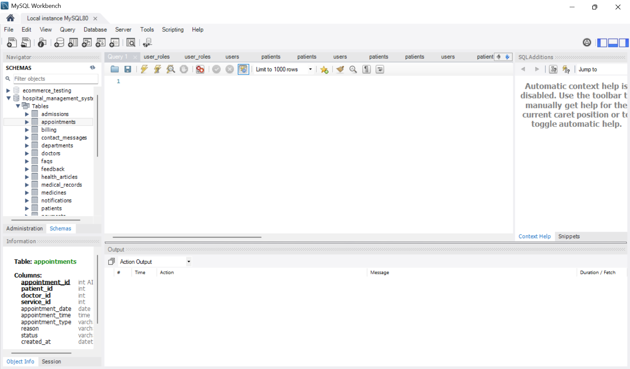

Step 03:
Data Insertion:
MODULE 01: USER & PATIENT MANAGEMENT
TABLE 01: user_roles
INSERT INTO user_roles (role_name, description, status)
VALUES
('Admin', 'System administrator with full access', 'Active'),
('Doctor', 'Medical professional who manages patients and medical records', 'Active'),
('Receptionist', 'Manages appointments and patient registration', 'Active'),
('Patient', 'Hospital patient who can book appointments and view medical information', 'Active'),
('Accountant', 'Manages billing and payment information', 'Active'),
('Content Manager', 'Manages website pages, health articles and FAQs', 'Active');
TABLE 02: users
INSERT INTO users (
role_id,
username,
email,
password_hash,
first_name,
last_name,
phone,
status
)
VALUES
(1, 'admin01', 'admin@hospital.com', 'hash_admin_123', 'John', 'Admin', '01710000001', 'Active'),
(2, 'doctor01', 'doctor1@hospital.com', 'hash_doctor_123', 'Sarah', 'Ahmed', '01710000002', 'Active'),
(2, 'doctor02', 'doctor2@hospital.com', 'hash_doctor_456', 'David', 'Rahman', '01710000003', 'Active'),
(3, 'reception01', 'reception@hospital.com', 'hash_reception_123', 'Maya', 'Akter', '01710000004', 'Active'),
(4, 'patient01', 'patient1@gmail.com', 'hash_patient_123', 'Tasnim', 'Jannat', '01710000005', 'Active'),
(4, 'patient02', 'patient2@gmail.com', 'hash_patient_456', 'Nadia', 'Islam', '01710000006', 'Active'),
(5, 'accountant01', 'accountant@hospital.com', 'hash_account_123', 'Michael', 'Khan', '01710000007', 'Active'),
(6, 'content01', 'content@hospital.com', 'hash_content_123', 'Emily', 'Das', '01710000008', 'Active'),
(4, 'patient03', 'patient3@gmail.com', 'hash_patient_789', 'Yeasin', 'Arafat', '01843000005', 'Active'),
(4, 'patient04', 'patient4@gmail.com', 'hash_patient_890', 'Yeasmin', 'Arifa', '01843000001', 'Active'),
(4, 'patient05', 'patient5@gmail.com', 'hash_patient_901', 'Tasmin', 'Jannat', '0180800005', 'Active'),
(4, 'patient06', 'patient6@gmail.com', 'hash_patient_012', 'Nihal', 'Hossen', '01543000903', 'Active'),
(2, 'doctor03', 'doctor3@hospital.com', 'hash_doctor_003', 'Robert', 'Hasan', '01710000011', 'Active'),
(2, 'doctor04', 'doctor4@hospital.com', 'hash_doctor_004', 'Maria', 'Akter', '01710000012', 'Active'),
(2, 'doctor05', 'doctor5@hospital.com', 'hash_doctor_005', 'Daniel', 'Rahman', '01710000013', 'Active'),
(2, 'doctor06', 'doctor6@hospital.com', 'hash_doctor_006', 'Nusrat', 'Jahan', '01710000014', 'Active'),
(2, 'doctor07', 'doctor7@hospital.com', 'hash_doctor_007', 'Arif', 'Hossain', '01710000015', 'Active'),
(2, 'doctor08', 'doctor8@hospital.com', 'hash_doctor_008', 'Sadia', 'Islam', '01710000016', 'Active');
TABLE 03: patients
INSERT INTO patients (
user_id,
date_of_birth,
gender,
blood_group,
address,
emergency_contact_name,
emergency_contact_phone,
insurance_number
)
VALUES
(5, '1998-05-15', 'Female', 'B+', 'Dhaka, Bangladesh', 'Rahim Ahmed', '01711000001', 'INS-10001'),
(6, '1995-09-20', 'Male', 'O+', 'Chittagong, Bangladesh', 'Karim Islam', '01711000002', 'INS-10002'),
(7, '1996-03-12', 'Male', 'O+', 'Rajshahi, Bangladesh', 'Yeasin Arafat', '01843000005', 'INS-10003'),
(8, '1997-02-15', 'Female', 'A+', 'Rangpur, Bangladesh', 'Yeasmin Arifa', '01843000001', 'INS-10004'),
(9, '1999-03-12', 'Female', 'AB+', 'Cox''s Bazar, Bangladesh', 'Tasmin Jannat', '0180800005', 'INS-10005'),
(10, '2000-03-09', 'Male', 'B+', 'Khulna, Bangladesh', 'Nihal Hossen', '01543000903', 'INS-10006');
MODULE 02: HOSPITAL MANAGEMENT
TABLE 04: departments
INSERT INTO departments (
department_name,
description,
location,
phone,
status
)
VALUES
('Cardiology', 'Department specializing in heart and cardiovascular diseases', 'Building A - 2nd Floor', '02-41000001', 'Active'),
('Neurology', 'Department specializing in disorders of the nervous system', 'Building A - 3rd Floor', '02-41000002', 'Active'),
('Orthopedics', 'Department specializing in bones, joints and musculoskeletal conditions', 'Building B - 2nd Floor', '02-41000003', 'Active'),
('Pediatrics', 'Department providing medical care for infants, children and adolescents', 'Building B - 3rd Floor', '02-41000004', 'Active'),
('Emergency', 'Department providing immediate medical care for emergency conditions', 'Ground Floor', '02-41000005', 'Active'),
('Dermatology', 'Department specializing in skin, hair and nail conditions','Building C - 2nd Floor', '02-41000006', 'Active'),
('Gynecology', 'Department providing healthcare related to womens reproductive health', 'Building C - 3rd Floor','02-41000007', 'Active'),
('Radiology', 'Department providing diagnostic imaging services such as X-Ray, CT and MRI', 'Building D - 1st Floor', '02-41000008','Active');
TABLE 05: doctors
INSERT INTO doctors (
user_id,
department_id,
specialization,
license_number,
qualification,
joining_date,
consultation_fee,
status
)
VALUES
(2, 1, 'Cardiologist', 'LIC-DOC-1001', 'MBBS, MD Cardiology', '2022-01-15', 1200.00, 'Active'),
(3, 2, 'Neurologist', 'LIC-DOC-1002', 'MBBS, FCPS Neurology', '2021-06-20', 1500.00, 'Active'),
(11, 3, 'Orthopedic Surgeon', 'LIC-DOC-1003', 'MBBS, MS Orthopedics', '2020-03-10', 1300.00, 'Active'),
(12, 4, 'Pediatrician', 'LIC-DOC-1004', 'MBBS, FCPS Pediatrics','2023-02-01', 1000.00, 'Active'),
(13, 5, 'Emergency Medicine Specialist', 'LIC-DOC-1005', 'MBBS, FCPS Emergency Medicine', '2019-08-15', 1100.00, 'Active'),
(14, 6, 'Dermatologist', 'LIC-DOC-1006', 'MBBS, DDV', '2022-11-05', 1200.00, 'Active'),
(15, 7, 'Gynecologist', 'LIC-DOC-1007', 'MBBS, FCPS Gynecology', '2020-09-12', 1400.00, 'Active'),
(16, 8, 'Radiologist', 'LIC-DOC-1008', 'MBBS, MD Radiology', '2021-04-18', 1600.00,'Active');
TABLE 06: rooms
INSERT INTO rooms (
room_number,
room_type,
floor_number,
bed_count,
available_beds,
daily_rate,
status
)
VALUES
('101', 'General Ward', 1, 10, 6, 1500.00, 'Available'),
('102', 'General Ward', 1, 10, 4, 1500.00, 'Available'),
('201', 'Private Room', 2, 1, 1, 3500.00, 'Available'),
('202', 'Private Room', 2, 1, 0, 3500.00, 'Occupied'),
('203', 'Private Room', 2, 1, 1, 3500.00, 'Available'),
('301', 'Semi-Private', 3, 2, 1, 2500.00, 'Available'),
('302', 'Semi-Private', 3, 2, 0, 2500.00, 'Occupied'),
('401', 'ICU', 4, 4, 2, 5000.00, 'Available'),
('402', 'ICU', 4, 4, 0, 5000.00, 'Occupied'),
('501', 'Emergency Room', 5, 5, 3, 3000.00, 'Available'),
('502', 'Emergency Room', 5, 5, 0, 3000.00, 'Occupied'),
('601', 'Maternity Room', 6, 2, 2, 2800.00, 'Available');
TABLE 07: admissions
INSERT INTO admissions (
patient_id,
doctor_id,
room_id,
admission_date,
discharge_date,
admission_reason,
status
)
VALUES
(1, 1, 4, '2026-01-05 10:30:00', '2026-01-10 14:00:00', 'Chest pain and cardiovascular evaluation', 'Discharged'),
(2, 2, 7, '2026-01-12 09:15:00', NULL, 'Neurological observation and treatment', 'Admitted'),
(3, 1, 5, '2026-02-03 11:00:00', '2026-02-07 16:30:00', 'Severe abdominal pain', 'Discharged'),
(4, 3, 8, '2026-02-15 18:45:00', NULL, 'Emergency medical observation', 'Admitted'),
(1, 2, 10, '2026-03-01 08:30:00', '2026-03-03 12:00:00', 'High fever and dehydration', 'Discharged'),
(2, 4, 12, '2026-03-10 13:00:00', NULL, 'Post-operative monitoring', 'Admitted'),
(3, 5, 3, '2026-03-18 15:20:00', '2026-03-22 11:00:00', 'Orthopedic treatment', 'Discharged'),
(4, 6, 9, '2026-04-02 20:00:00', NULL, 'Critical care and continuous monitoring', 'Admitted')
(1, 3, 2, '2026-04-15 09:00:00', '2026-04-18 15:00:00', 'Respiratory infection', 'Discharged'),
(2, 8, 6, '2026-05-05 10:45:00', NULL, 'General medical observation', 'Admitted');
MODULE 03: APPOINTMENT & MEDICAL MANAGEMENT
TABLE 08: services
INSERT INTO services (
department_id,
service_name,
description,
service_fee,
duration_minutes,
status
)
VALUES
(1, 'Cardiology Consultation', 'Heart and cardiovascular disease consultation with a cardiologist', 1200.00, 30, 'Active'),
(1, 'ECG Test', 'Electrocardiogram test to monitor heart activity', 800.00, 20, 'Active'),
(2, 'Neurology Consultation', 'Consultation for neurological disorders and nervous system conditions', 1500.00, 40, 'Active'),
(2, 'EEG Test', 'Electroencephalogram test to measure brain electrical activity', 2000.00, 45, 'Active'),
(3, 'Orthopedic Consultation', 'Consultation for bones, joints and musculoskeletal conditions', 1300.00, 30, 'Active'),
(3, 'X-Ray Examination', 'Diagnostic X-ray examination for bones and joints',700.00, 20, 'Active'),
(4, 'Pediatric Consultation', 'Medical consultation and treatment for children', 1000.00, 30, 'Active'),
(5, 'Emergency Consultation', 'Immediate medical assessment and emergency treatment', 2000.00, 30, 'Active'),
(6, 'Dermatology Consultation', 'Diagnosis and treatment of skin, hair and nail conditions', 1100.00, 30, 'Active'),
(6, 'Skin Allergy Test', 'Diagnostic testing for common skin allergies', 1500.00, 40, 'Active'),
(7, 'Gynecology Consultation', 'Women’s reproductive health consultation and examination', 1300.00, 30, 'Active'),
(7, 'Pregnancy Checkup', 'Routine pregnancy health checkup and consultation', 1200.00, 40, 'Active'),
(8, 'MRI Scan', 'Magnetic resonance imaging for detailed diagnostic examination', 6000.00, 60, 'Active'),
(8, 'CT Scan', 'Computed tomography scan for detailed internal imaging', 4000.00, 45, 'Active'),
(8, 'Ultrasound', 'Ultrasound imaging for diagnostic examination', 1800.00, 30, 'Active');
TABLE 09: appointments
INSERT INTO appointments (
patient_id,
doctor_id,
service_id,
appointment_date,
appointment_time,
appointment_type,
reason,
status
)
VALUES
(
1,
(SELECT doctor_id FROM doctors WHERE specialization = 'Cardiologist' LIMIT 1),
1,
'2026-01-08',
'10:00:00',
'In-Person',
'Regular heart checkup',
'Completed'
),
(
2,
(SELECT doctor_id FROM doctors WHERE specialization = 'Neurologist' LIMIT 1),
3,
'2026-01-15',
'11:30:00',
'In-Person',
'Headache and neurological evaluation',
'Completed'
),
(
3,
(SELECT doctor_id FROM doctors WHERE specialization = 'Orthopedic Surgeon' LIMIT 1),
5,
'2026-02-05',
'09:30:00',
'In-Person',
'Knee pain and joint examination',
'Completed'
),
(
4,
(SELECT doctor_id FROM doctors WHERE specialization = 'Pediatrician' LIMIT 1),
7,
'2026-02-18',
'14:00:00',
'In-Person',
'Child health checkup',
'Completed'
),
(
1,
(SELECT doctor_id FROM doctors WHERE specialization = 'Emergency Medicine Specialist' LIMIT 1),
8,
'2026-03-02',
'18:30:00',
'Emergency',
'Sudden high fever and weakness',
'Completed'
),
(
2,
(SELECT doctor_id FROM doctors WHERE specialization = 'Dermatologist' LIMIT 1),
9,
'2026-03-12',
'10:30:00',
'Online',
'Skin allergy consultation',
'Confirmed'
),
(
3,
(SELECT doctor_id FROM doctors WHERE specialization = 'Radiologist' LIMIT 1),
13,
'2026-03-20',
'15:00:00',
'In-Person',
'MRI diagnostic examination',
'Scheduled'
),
(
4,
(SELECT doctor_id FROM doctors WHERE specialization = 'Radiologist' LIMIT 1),
14,
'2026-04-05',
'12:00:00',
'In-Person',
'CT scan for diagnostic evaluation',
'Scheduled'
),
(
1,
(SELECT doctor_id FROM doctors WHERE specialization = 'Cardiologist' LIMIT 1),
2,
'2026-04-15',
'09:00:00',
'Follow-Up',
'Follow-up ECG examination',
'Confirmed'
),
(
2,
(SELECT doctor_id FROM doctors WHERE specialization = 'Neurologist' LIMIT 1),
4,
'2026-04-20',
'13:30:00',
'In-Person',
'EEG examination',
'Scheduled'
),
(
3,
(SELECT doctor_id FROM doctors WHERE specialization = 'Orthopedic Surgeon' LIMIT 1),
6,
'2026-05-05',
'10:00:00',
'Follow-Up',
'Follow-up orthopedic consultation',
'Scheduled'
),
(
4,
(SELECT doctor_id FROM doctors WHERE specialization = 'Gynecologist' LIMIT 1),
12,
'2026-05-12',
'11:00:00',
'In-Person',
'Pregnancy health checkup',
'Confirmed'
),
(
1,
(SELECT doctor_id FROM doctors WHERE specialization = 'Dermatologist' LIMIT 1),
10,
'2026-05-18',
'14:30:00',
'In-Person',
'Skin allergy testing',
'Scheduled'
),
(
2,
(SELECT doctor_id FROM doctors WHERE specialization = 'Gynecologist' LIMIT 1),
11,
'2026-06-01',
'10:30:00',
'In-Person',
'Gynecology consultation',
'Scheduled'
);
TABLE 10: medical_records
INSERT INTO medical_records (
patient_id,
doctor_id,
appointment_id,
diagnosis,
symptoms,
treatment,
notes,
record_date
)
VALUES
(1, 1, 1, 'Hypertension', 'Occasional headache and elevated blood pressure', 'Prescribed antihypertensive medication and advised regular exercise', 'Patient advised to monitor blood pressure regularly', '2026-01-08 11:00:00'),
(2, 2, 2, 'Migraine', 'Severe headache, nausea and sensitivity to light', 'Prescribed migraine medication and advised adequate rest', 'Follow-up recommended if symptoms persist', '2026-01-15 12:30:00'),
(3, 3, 3, 'Knee Arthritis', 'Knee pain, stiffness and difficulty walking', 'Pain medication and physical therapy recommended', 'Avoid excessive pressure on the affected knee', '2026-02-05 10:30:00'),
(4, 4, 4, 'Viral Infection', 'Fever, cough and weakness', 'Prescribed medication and advised adequate fluids and rest', 'Patient should return if fever continues', '2026-02-18 15:00:00'),
(1, 5, 5, 'Acute Fever', 'High fever, weakness and dehydration', 'Fluids, fever-reducing medication and observation', 'Emergency symptoms monitored and condition stabilized', '2026-03-02 19:30:00'),
(2, 6, 6, 'Skin Allergy', 'Skin rash, itching and redness', 'Antihistamine medication and topical treatment', 'Avoid suspected allergens', '2026-03-12 11:30:00'),
(3, 8, 7, 'Spinal Abnormality', 'Back pain and discomfort', 'MRI recommended for further evaluation', 'MRI findings should be reviewed during follow-up', '2026-03-20 16:00:00'),
(4, 8, 8, 'Chest Abnormality', 'Chest discomfort and breathing difficulty', 'CT scan performed for diagnostic evaluation', 'Further clinical evaluation recommended', '2026-04-05 13:00:00'),
(1, 1, 9, 'Hypertension Follow-Up', 'Occasional elevated blood pressure', 'Continue prescribed medication and lifestyle changes', 'Blood pressure improving', '2026-04-15 10:00:00'),
(2, 2, 10 'Migraine Follow-Up', 'Recurring headache', 'Continue prescribed migraine treatment', 'Patient responding well to treatment', '2026-04-20 14:30:00'),
(3, 3, 11, 'Knee Arthritis Follow-Up', 'Reduced knee pain with mild stiffness', 'Continue physical therapy', 'Patient showing improvement', '2026-05-05 11:00:00'),
(4, 7, 12,'Pregnancy Monitoring', 'Routine pregnancy monitoring', 'Regular prenatal checkups recommended', 'Continue scheduled prenatal visits', '2026-05-12 12:00:00'),
(1, 6, 13, 'Allergic Skin Reaction', 'Mild skin irritation and itching', 'Allergy test performed and treatment advised', 'Follow-up if symptoms worsen', '2026-05-18 15:30:00'),
(2, 7, 14, 'Gynecological Evaluation', 'Routine health evaluation', 'Further diagnostic examination recommended', 'Follow-up appointment scheduled', '2026-06-01 11:30:00');
TABLE 11: prescriptions
INSERT INTO prescriptions (
patient_id,
doctor_id,
record_id,
prescription_date,
instructions,
status
)
VALUES
(1, 1, 1, '2026-01-08', 'Take prescribed blood pressure medicine once daily after breakfast. Monitor blood pressure regularly.', 'Active'),
(2, 2, 2, '2026-01-15', 'Take migraine medication when symptoms occur. Get adequate sleep and avoid bright light.', 'Completed'),
(3, 3, 3, '2026-02-05', 'Take pain medication after meals and continue recommended physical therapy exercises.', 'Active'),
(4, 4, 4, '2026-02-18', 'Take prescribed medicine twice daily. Drink plenty of fluids and take adequate rest.', 'Completed'),
(1, 5, 5, '2026-03-02', 'Take fever-reducing medication as prescribed and maintain adequate hydration.', 'Completed'),
(2, 6, 6, '2026-03-12', 'Apply prescribed topical treatment twice daily and take antihistamine as directed.', 'Active'),
(3, 8, 7, '2026-03-20', 'Take medication as prescribed and follow up after MRI results are available.', 'Active'),
(4, 8, 8, '2026-04-05', 'Continue prescribed treatment and return for further evaluation if breathing difficulty increases.', 'Active'),
(1, 1, 9, '2026-04-15', 'Continue blood pressure medication and maintain a low-sodium diet.', 'Completed'),
(2, 2, 10, '2026-04-20', 'Continue migraine treatment and avoid known migraine triggers.', 'Active'),
(3, 3, 11, '2026-05-05', 'Continue physical therapy and use pain medication when required.', 'Completed'),
(4, 7, 12, '2026-05-12', 'Take prenatal supplements as prescribed and attend regular prenatal checkups.', 'Active'),
(1, 6, 13, '2026-05-18', 'Apply allergy treatment as directed and avoid identified allergens.', 'Active'),
(2, 7, 14, '2026-06-01', 'Take prescribed medication as directed and attend the recommended follow-up appointment.', 'Active');
TABLE 12: medicines
INSERT INTO medicines (
medicine_name,
category,
manufacturer,
unit_price,
stock_quantity,
expiry_date,
status
)
VALUES
('Amlodipine 5mg', 'Antihypertensive', 'Square Pharmaceuticals', 3.50, 500, '2028-06-30', 'Available'),
('Losartan 50mg', 'Antihypertensive', 'Beximco Pharmaceuticals', 4.00, 350, '2028-09-30', 'Available'),
('Paracetamol 500mg', 'Painkiller', 'Renata Limited', 2.00, 1000, '2029-01-31', 'Available'),
('Ibuprofen 400mg', 'Painkiller', 'ACI Limited', 5.50, 450, '2028-11-30', 'Available'),
('Omeprazole 20mg', 'Gastric Medicine', 'Incepta Pharmaceuticals', 4.50, 600, '2028-07-31', 'Available'),
('Cetirizine 10mg', 'Antihistamine', 'Eskayef Pharmaceuticals', 3.00, 400, '2028-10-31', 'Available'),
('Azithromycin 500mg', 'Antibiotic', 'Square Pharmaceuticals', 15.00, 250, '2028-05-31', 'Available'),
('Amoxicillin 500mg', 'Antibiotic', 'Beximco Pharmaceuticals', 12.00, 300, '2028-08-31', 'Available'),
('Metformin 500mg', 'Antidiabetic', 'Renata Limited', 3.00, 550, '2029-02-28', 'Available'),
('Atorvastatin 20mg', 'Cholesterol Medicine', 'Incepta Pharmaceuticals', 6.00, 275, '2028-12-31', 'Available'),
('Salbutamol Inhaler', 'Respiratory Medicine', 'GlaxoSmithKline', 120.00, 80, '2027-12-31', 'Available'),
('Pantoprazole 40mg', 'Gastric Medicine', 'Healthcare Pharmaceuticals', 7.00, 200, '2028-04-30', 'Available'),
('Diclofenac 50mg', 'Anti-inflammatory', 'Opsonin Pharma', 3.50, 150, '2027-10-31', 'Available'),
('Insulin Glargine', 'Insulin', 'Novo Nordisk', 850.00, 35, '2027-06-30', 'Available'),
('ORS Powder', 'Electrolyte', 'ACI Limited', 5.00, 0, '2028-03-31', 'Out of Stock'),
('Calcium + Vitamin D', 'Supplement', 'Square Pharmaceuticals', 4.00, 180, '2027-09-30', 'Available'),
('Montelukast 10mg', 'Respiratory Medicine', 'Incepta Pharmaceuticals', 8.00, 120, '2026-08-31', 'Expired'),
('Hydrocortisone Cream', 'Dermatological', 'Renata Limited', 35.00, 0, '2028-01-31', 'Out of Stock'),
('Clotrimazole Cream', 'Antifungal', 'Opsonin Pharma', 45.00, 90, '2028-06-30', 'Available'),
('Vitamin B Complex', 'Vitamin', 'Beximco Pharmaceuticals', 2.50, 300, '2029-03-31', 'Available');
TABLE 13: prescription_medicines
INSERT INTO prescription_medicines (
prescription_id,
medicine_id,
dosage,
frequency,
duration,
quantity
)
VALUES
-- Prescription 1: Hypertension
(1, 1, '5mg', 'Once daily', '30 days', 30),
(1, 2, '50mg', 'Once daily', '30 days', 30),
-- Prescription 2: Migraine
(2, 3, '500mg', 'When needed', '10 days', 10),
(2, 4, '400mg', 'Twice daily', '5 days', 10),
-- Prescription 3: Knee Arthritis
(3, 4, '400mg', 'Twice daily', '10 days', 20),
(3, 13, '50mg', 'Once daily', '10 days', 10),
-- Prescription 4: Viral Infection
(4, 3, '500mg', 'Three times daily', '5 days', 15),
(4, 5, '20mg', 'Once daily', '5 days', 5),
-- Prescription 5: Acute Fever
(5, 3, '500mg', 'Three times daily', '5 days', 15),
(5, 15, '1 sachet', 'Twice daily', '3 days', 6),
-- Prescription 6: Skin Allergy
(6, 6, '10mg', 'Once daily', '10 days', 10),
(6, 18, 'Apply thin layer', 'Twice daily', '7 days', 1),
-- Prescription 7: Spinal Abnormality
(7, 4, '400mg', 'Twice daily', '7 days', 14),
(7, 13, '50mg', 'Once daily', '7 days', 7),
-- Prescription 8: Chest Abnormality
(8, 11, '2 puffs', 'Twice daily', '14 days', 1),
(8, 6, '10mg', 'Once daily', '14 days', 14),
-- Prescription 9: Hypertension Follow-Up
(9, 1, '5mg', 'Once daily', '30 days', 30),
-- Prescription 10: Migraine Follow-Up
(10, 3, '500mg', 'When needed', '15 days', 15),
-- Prescription 11: Knee Arthritis Follow-Up
(11, 13, '50mg', 'Once daily', '10 days', 10),
(11, 4, '400mg', 'Twice daily', '10 days', 20),
-- Prescription 12: Pregnancy Monitoring
(12, 16, '1 tablet', 'Once daily', '30 days', 30),
-- Prescription 13: Allergic Skin Reaction
(13, 6, '10mg', 'Once daily', '10 days', 10),
(13, 19, 'Apply thin layer', 'Twice daily', '14 days', 1),
-- Prescription 14: Gynecological Evaluation
(14, 5, '20mg', 'Once daily', '14 days', 14),
(14, 16, '1 tablet', 'Once daily', '30 days', 30);
MODULE 04: BILLING & PAYMENT
TABLE 14: billing
INSERT INTO billing (
patient_id,
appointment_id,
admission_id,
bill_date,
consultation_fee,
medicine_fee,
room_fee,
test_fee,
discount,
tax,
total_amount,
payment_status
)
VALUES
(1, 1, 1, '2026-01-10 14:30:00',
1200.00, 250.00, 7500.00, 800.00, 200.00, 465.00,
10015.00, 'Paid'),

(2, 2, 2, '2026-01-20 11:00:00',
1500.00, 300.00, 12500.00, 2000.00, 500.00, 790.00,
16590.00, 'Partial'),

(3, 3, 3, '2026-02-07 16:00:00',
1300.00, 450.00, 14000.00, 700.00, 300.00, 807.50,
16957.50, 'Paid'),

(4, 4, 4, '2026-02-18 17:00:00',
1000.00, 200.00, 15000.00, 0.00, 0.00, 810.00,
17010.00, 'Pending'),

(1, 5, 5, '2026-03-03 12:30:00',
2000.00, 150.00, 6000.00, 0.00, 250.00, 395.00,
8295.00, 'Paid'),

(2, 6, 6, '2026-03-10 15:00:00',
1100.00, 350.00, 17500.00, 1500.00, 500.00, 997.50,
20947.50, 'Partial'),

(3, 7, 7, '2026-03-22 11:30:00',
1300.00, 500.00, 14000.00, 6000.00, 1000.00, 1040.00,
21840.00, 'Paid'),

(4, 8, 8, '2026-04-05 14:00:00',
2000.00, 850.00, 15000.00, 4000.00, 500.00, 1575.00,
22925.00, 'Pending'),

(1, 9, 9, '2026-04-18 15:30:00',
1200.00, 200.00, 4500.00, 800.00, 100.00, 330.00,
6930.00, 'Paid'),

(2, 10, 10, '2026-04-20 15:00:00',
1500.00, 300.00, 3500.00, 2000.00, 200.00, 710.00,
7810.00, 'Partial');
TABLE 15: payments
INSERT INTO payments (
bill_id,
payment_date,
amount_paid,
payment_method,
transaction_reference,
payment_status
)
VALUES
(1, '2026-01-10 15:00:00', 10015.00, 'Card', 'TXN-20260110-001', 'Completed'),

(2, '2026-01-20 12:00:00', 8000.00, 'Mobile Banking', 'TXN-20260120-002', 'Completed'),

(3, '2026-02-07 16:30:00', 16957.50, 'Cash', 'TXN-20260207-003', 'Completed'),

(4, '2026-02-18 17:30:00', 5000.00, 'Cash', 'TXN-20260218-004', 'Pending'),

(5, '2026-03-03 13:00:00', 8295.00, 'Bank Transfer', 'TXN-20260303-005', 'Completed'),

(6, '2026-03-10 15:30:00', 10000.00, 'Card', 'TXN-20260310-006', 'Completed'),

(7, '2026-03-22 12:00:00', 21840.00, 'Insurance', 'TXN-20260322-007', 'Completed'),

(8, '2026-04-05 14:30:00', 7000.00, 'Mobile Banking', 'TXN-20260405-008', 'Completed'),

(9, '2026-04-18 16:00:00', 6930.00, 'Card', 'TXN-20260418-009', 'Completed'),

(10, '2026-04-20 15:30:00', 4000.00, 'Cash', 'TXN-20260420-010', 'Completed');
MODULE 05: WEBSITE CONTENT MANAGEMENT
TABLE 16: website_pages
INSERT INTO website_pages (
page_title,
page_slug,
page_content,
meta_title,
meta_description,
status,
created_by,
created_at,
updated_at
)
VALUES
(
'Home',
'home',
'Welcome to our hospital. We provide quality healthcare services through experienced doctors, modern facilities and patient-centered care.',
'Home - Hospital Management System',
'Welcome to our hospital for quality healthcare services, experienced doctors and modern medical facilities.',
'Published',
8,
'2026-01-01 09:00:00',
'2026-01-05 10:30:00'
),

(
'About Us',
'about-us',
'Our hospital is committed to providing safe, affordable and high-quality healthcare services to patients and their families.',
'About Us - Our Hospital',
'Learn about our hospital, healthcare mission, medical team and commitment to quality patient care.',
'Published',
8,
'2026-01-02 10:00:00',
'2026-01-06 11:00:00'
),

(
'Our Services',
'services',
'We offer cardiology, neurology, orthopedics, pediatrics, dermatology, gynecology, radiology and emergency medical services.',
'Hospital Services',
'Explore our medical services including cardiology, neurology, orthopedics, pediatrics and emergency care.',
'Published',
8,
'2026-01-03 09:30:00',
'2026-01-07 12:00:00'
),

(
'Our Doctors',
'doctors',
'Our experienced medical professionals provide specialized healthcare services across multiple departments.',
'Our Doctors - Medical Specialists',
'Meet our experienced doctors and medical specialists providing professional healthcare services.',
'Published',
8,
'2026-01-04 10:30:00',
'2026-01-08 13:00:00'
),

(
'Emergency Services',
'emergency-services',
'Our emergency department provides immediate medical attention for patients requiring urgent and critical care.',
'Emergency Services - Hospital',
'Get information about our emergency department and immediate medical care services.',
'Published',
8,
'2026-01-05 11:00:00',
'2026-01-09 14:00:00'
),

(
'Contact Us',
'contact-us',
'Contact our hospital for appointments, medical inquiries, emergency assistance and general information.',
'Contact Us - Hospital',
'Contact our hospital for appointments, healthcare information and medical assistance.',
'Published',
8,
'2026-01-06 09:00:00',
'2026-01-10 10:00:00'
),

(
'Privacy Policy',
'privacy-policy',
'This privacy policy explains how the hospital collects, uses and protects patient and website visitor information.',
'Privacy Policy - Hospital',
'Read our privacy policy and learn how patient and visitor information is protected.',
'Published',
8,
'2026-01-07 12:00:00',
NULL
),

(
'Terms and Conditions',
'terms-and-conditions',
'These terms and conditions describe the rules and requirements for using our hospital website and online services.',
'Terms and Conditions - Hospital',
'Review the terms and conditions for using our hospital website and online services.',
'Draft',
8,
'2026-01-08 15:00:00',
NULL
);
TABLE 17: health_articles
INSERT INTO health_articles (
title,
slug,
category,
content,
author_id,
thumbnail_url,
status,
published_at,
created_at,
updated_at
)
VALUES
(
'10 Tips for Maintaining a Healthy Heart',
'10-tips-healthy-heart',
'Cardiology',
'A healthy heart is essential for overall well-being. Regular exercise, a balanced diet, maintaining a healthy weight, controlling blood pressure and avoiding smoking can help reduce the risk of cardiovascular disease.',
8,
'https://example.com/images/healthy-heart.jpg',
'Published',
'2026-01-10 09:00:00',
'2026-01-05 10:00:00',
'2026-01-10 09:00:00'
),

(
'Understanding Migraine and Its Symptoms',
'understanding-migraine-symptoms',
'Neurology',
'Migraine is a neurological condition that can cause severe headaches, nausea and sensitivity to light or sound. Identifying triggers and following appropriate treatment can help manage migraine symptoms.',
8,
'https://example.com/images/migraine.jpg',
'Published',
'2026-01-15 10:30:00',
'2026-01-08 11:00:00',
'2026-01-15 10:30:00'
),

(
'How to Protect Your Joints',
'how-to-protect-your-joints',
'Orthopedics',
'Maintaining a healthy weight, staying physically active and using proper techniques during exercise can help protect joints and reduce the risk of musculoskeletal problems.',
8,
'https://example.com/images/joints.jpg',
'Published',
'2026-02-05 09:30:00',
'2026-01-20 12:00:00',
'2026-02-05 09:30:00'
),

(
'Importance of Childhood Vaccination',
'importance-childhood-vaccination',
'Pediatrics',
'Vaccination protects children from several preventable infectious diseases. Parents should follow the recommended vaccination schedule and consult qualified healthcare professionals when they have questions.',
8,
'https://example.com/images/vaccination.jpg',
'Published',
'2026-02-12 11:00:00',
'2026-02-01 10:00:00',
'2026-02-12 11:00:00'
),

(
'Managing Common Skin Allergies',
'managing-common-skin-allergies',
'Dermatology',
'Skin allergies may cause redness, itching, swelling or irritation. Identifying possible allergens and following appropriate medical advice can help manage symptoms.',
8,
'https://example.com/images/skin-allergy.jpg',
'Published',
'2026-02-20 14:00:00',
'2026-02-10 09:00:00',
'2026-02-20 14:00:00'
),

(
'Women’s Health: Regular Checkups',
'womens-health-regular-checkups',
'Gynecology',
'Regular healthcare checkups can help identify potential health concerns early. Women should discuss appropriate examinations and preventive healthcare with qualified healthcare professionals.',
8,
'https://example.com/images/womens-health.jpg',
'Published',
'2026-03-05 10:00:00',
'2026-02-15 11:00:00',
'2026-03-05 10:00:00'
),

(
'Understanding Diabetes and Blood Sugar',
'understanding-diabetes-blood-sugar',
'Diabetes',
'Diabetes affects how the body processes blood glucose. Healthy eating, regular physical activity, monitoring blood glucose and following medical advice are important parts of diabetes management.',
8,
'https://example.com/images/diabetes.jpg',
'Published',
'2026-03-15 09:00:00',
'2026-03-01 10:00:00',
'2026-03-15 09:00:00'
),

(
'Healthy Eating for a Stronger Immune System',
'healthy-eating-immune-system',
'Nutrition',
'A balanced diet containing vegetables, fruits, whole grains, protein and adequate fluids supports overall health. Good nutrition is an important part of maintaining a healthy lifestyle.',
8,
'https://example.com/images/nutrition.jpg',
'Draft',
NULL,
'2026-03-20 13:00:00',
NULL
),

(
'When Should You Visit the Emergency Department?',
'when-to-visit-emergency-department',
'Emergency Care',
'Certain symptoms require immediate medical attention. Severe breathing difficulty, chest pain, serious injuries, loss of consciousness and other urgent conditions should be evaluated promptly by healthcare professionals.',
8,
'https://example.com/images/emergency-care.jpg',
'Published',
'2026-04-01 15:00:00',
'2026-03-25 10:00:00',
'2026-04-01 15:00:00'
),

(
'Preventing Common Seasonal Infections',
'preventing-seasonal-infections',
'General Health',
'Regular handwashing, maintaining good hygiene, getting adequate rest and following recommended preventive healthcare practices can reduce the spread of common infections.',
8,
'https://example.com/images/seasonal-infection.jpg',
'Archived',
'2026-01-20 10:00:00',
'2026-01-10 09:00:00',
'2026-04-05 12:00:00'
);
TABLE 18: faqs
INSERT INTO faqs (
question,
answer,
category,
display_order,
status,
created_by,
created_at,
updated_at
)
VALUES
(
'How can I book an appointment with a doctor?',
'You can book an appointment through the hospital website by selecting a department, doctor, available service and preferred appointment date and time.',
'Appointments',
1,
'Active',
8,
'2026-01-05 09:00:00',
'2026-01-05 09:00:00'
),

(
'Can I cancel my appointment?',
'Yes. You can cancel a scheduled appointment according to the hospital cancellation policy. Contact the reception desk if you need assistance.',
'Appointments',
2,
'Active',
8,
'2026-01-06 10:00:00',
NULL
),

(
'What should I bring for my first hospital visit?',
'Patients should bring a valid identification document, previous medical reports if available, prescription records and insurance information when applicable.',
'Patient Information',
3,
'Active',
8,
'2026-01-07 09:30:00',
NULL
),

(
'Does the hospital provide emergency services?',
'Yes. Our emergency department provides immediate medical assessment and treatment for patients requiring urgent medical attention.',
'Emergency',
4,
'Active',
8,
'2026-01-08 11:00:00',
'2026-01-10 12:00:00'
),

(
'What medical departments are available?',
'The hospital provides several departments including Cardiology, Neurology, Orthopedics, Pediatrics, Emergency, Dermatology, Gynecology and Radiology.',
'Hospital Services',
5,
'Active',
8,
'2026-01-09 10:00:00',
NULL
),

(
'Can I view my medical records online?',
'Registered patients may be able to view available medical information through the hospital patient portal, depending on the services provided by the hospital.',
'Patient Portal',
6,
'Active',
8,
'2026-01-10 14:00:00',
NULL
),

(
'What payment methods are accepted?',
'The hospital accepts several payment methods including cash, card, bank transfer, mobile banking and eligible insurance payments.',
'Billing and Payment',
7,
'Active',
8,
'2026-01-12 09:00:00',
NULL
),

(
'How can I contact the hospital?',
'You can contact the hospital through the contact form, telephone or by visiting the hospital reception desk during operating hours.',
'Contact',
8,
'Active',
8,
'2026-01-15 10:30:00',
NULL
),

(
'How can I find information about hospital services?',
'You can visit the Services section of the hospital website to view available medical services, departments, service fees and other information.',
'Hospital Services',
9,
'Active',
8,
'2026-01-18 11:00:00',
NULL
),

(
'Can I provide feedback about my hospital experience?',
'Yes. Patients can submit feedback and rate their hospital experience through the feedback section of the website.',
'Feedback',
10,
'Active',
8,
'2026-01-20 13:00:00',
NULL
),

(
'Are health articles available on the website?',
'Yes. The hospital website provides health-related articles covering topics such as heart health, nutrition, diabetes, skin health and preventive care.',
'Website',
11,
'Active',
8,
'2026-01-22 09:00:00',
NULL
),

(
'Can I access emergency services without an appointment?',
'Emergency patients can seek immediate medical attention without scheduling a regular appointment. Emergency cases are prioritized according to medical urgency.',
'Emergency',
12,
'Inactive',
8,
'2026-01-25 15:00:00',
'2026-02-01 10:00:00'
);
TABLE 19: contact_messages
INSERT INTO contact_messages (
name,
email,
phone,
subject,
message,
submitted_at,
status,
responded_by,
responded_at
)
VALUES
(
'Rahim Ahmed',
'rahim.ahmed@gmail.com',
'01711000001',
'Appointment Booking Issue',
'I am unable to book an appointment with the Cardiology department through the website.',
'2026-01-05 09:30:00',
'Resolved',
8,
'2026-01-05 14:00:00'
),

(
'Nadia Islam',
'nadia.islam@gmail.com',
'01711000002',
'Doctor Availability',
'I would like to know the available appointment times for a Neurology specialist.',
'2026-01-08 10:15:00',
'In Progress',
8,
'2026-01-08 12:00:00'
),

(
'Karim Hossain',
'karim.hossain@gmail.com',
'01811000003',
'Emergency Department Information',
'Please provide information about your emergency department and available services.',
'2026-01-12 11:20:00',
'New',
NULL,
NULL
),

(
'Mariam Akter',
'mariam.akter@gmail.com',
'01911000004',
'Billing Question',
'I would like clarification about the charges shown on my hospital bill.',
'2026-01-15 13:45:00',
'Resolved',
8,
'2026-01-16 10:30:00'
),

(
'Sakib Rahman',
'sakib.rahman@gmail.com',
'01611000005',
'Medical Report Request',
'I would like to know how I can obtain a copy of my recent medical report.',
'2026-01-20 09:10:00',
'In Progress',
8,
'2026-01-20 11:00:00'
),

(
'Farhana Yasmin',
'farhana.yasmin@gmail.com',
'01711000006',
'Pediatric Services',
'Could you please provide information about pediatric consultation services?',
'2026-01-25 15:30:00',
'New',
NULL,
NULL
),

(
'Tanvir Hasan',
'tanvir.hasan@gmail.com',
'01811000007',
'Website Feedback',
'The hospital website is useful, but I would like to see more information about doctor schedules.',
'2026-02-01 10:00:00',
'Closed',
8,
'2026-02-02 09:30:00'
),

(
'Sumaiya Chowdhury',
'sumaiya.chowdhury@gmail.com',
'01911000008',
'Insurance Information',
'Please let me know which insurance payment options are accepted by the hospital.',
'2026-02-05 14:20:00',
'Resolved',
8,
'2026-02-06 11:15:00'
),

(
'Imran Kabir',
'imran.kabir@gmail.com',
'01611000009',
'Contact Information',
'I would like to confirm the hospital contact number and operating hours.',
'2026-02-10 16:00:00',
'Closed',
8,
'2026-02-11 10:00:00'
),

(
'Jannatul Ferdous',
'jannatul.ferdous@gmail.com',
'01711000010',
'Dermatology Appointment',
'I need information about booking an appointment with a dermatologist.',
'2026-02-15 09:45:00',
'New',
NULL,
NULL
);
TABLE 20: feedback
INSERT INTO feedback (
patient_id,
appointment_id,
rating,
comments,
status,
submitted_at,
approved_by,
approved_at
)
VALUES
(
1,
1,
5,
'The doctor was very professional and explained my condition clearly. The staff were also helpful.',
'Approved',
'2026-01-11 10:30:00',
8,
'2026-01-11 14:00:00'
),

(
2,
2,
4,
'The consultation was good and the doctor was knowledgeable. The waiting time was slightly long.',
'Approved',
'2026-01-21 11:15:00',
8,
'2026-01-21 15:00:00'
),

(
3,
3,
5,
'Excellent orthopedic consultation. The doctor provided useful advice and treatment information.',
'Approved',
'2026-02-08 09:45:00',
8,
'2026-02-08 12:30:00'
),

(
4,
4,
3,
'The medical service was satisfactory, but the waiting area was crowded.',
'Pending',
'2026-02-19 16:00:00',
NULL,
NULL
),

(
1,
5,
4,
'The emergency staff responded quickly and provided good care.',
'Approved',
'2026-03-04 10:00:00',
8,
'2026-03-04 13:30:00'
),

(
2,
6,
2,
'The consultation was helpful, but I had to wait a long time before seeing the doctor.',
'Rejected',
'2026-03-11 14:20:00',
8,
'2026-03-12 10:00:00'
),

(
3,
7,
5,
'Very good service. The doctor explained the diagnostic procedure in detail.',
'Approved',
'2026-03-23 11:30:00',
8,
'2026-03-23 15:00:00'
),

(
4,
8,
4,
'The diagnostic service was good and the staff were supportive.',
'Pending',
'2026-04-06 09:30:00',
NULL,
NULL
),

(
1,
9,
5,
'The follow-up consultation was excellent. My condition has improved significantly.',
'Approved',
'2026-04-19 12:00:00',
8,
'2026-04-19 16:00:00'
),

(
2,
10,
4,
'Good consultation experience. The doctor listened carefully and provided clear instructions.',
'Pending',
'2026-04-21 10:45:00',
NULL,
NULL
);
TABLE 21: notifications
INSERT INTO notifications
(user_id, title, message, notification_type, reference_id, is_read, created_at, read_at, status)
VALUES

(1, 'New Appointment Booked',
'A new patient appointment has been scheduled.',
'Appointment', 1, TRUE,
'2026-08-20 09:15:00', '2026-08-20 09:30:00', 'Active'),

(2, 'Appointment Reminder',
'You have an upcoming appointment with a patient tomorrow.',
'Appointment', 2, FALSE,
'2026-08-20 10:00:00', NULL, 'Active'),

(3, 'New Medical Record',
'A new medical record has been added to your account.',
'Medical Record', 3, TRUE,
'2026-08-20 11:20:00', '2026-08-20 11:45:00', 'Active'),

(4, 'Prescription Created',
'A new prescription has been created for your patient.',
'Prescription', 4, FALSE,
'2026-08-21 08:30:00', NULL, 'Active'),

(5, 'Payment Received',
'Payment has been successfully received for Bill #1.',
'Payment', 1, TRUE,
'2026-08-21 09:10:00', '2026-08-21 09:25:00', 'Active'),

(6, 'New Contact Message',
'A new message has been submitted through the hospital website.',
'Contact Message', 2, FALSE,
'2026-08-21 10:15:00', NULL, 'Active'),

(7, 'Feedback Submitted',
'A patient has submitted new feedback for an appointment.',
'Feedback', 1, TRUE,
'2026-08-21 12:00:00', '2026-08-21 12:20:00', 'Active'),

(8, 'Health Article Published',
'A new health article has been published on the hospital website.',
'Website', 5, TRUE,
'2026-08-22 09:00:00', '2026-08-22 09:15:00', 'Active'),

(11, 'Appointment Cancelled',
'An appointment has been cancelled by the patient.',
'Appointment', 5, FALSE,
'2026-08-22 10:30:00', NULL, 'Active'),

(12, 'Patient Admission',
'A patient has been admitted to the hospital.',
'Admission', 3, TRUE,
'2026-08-22 11:45:00', '2026-08-22 12:00:00', 'Active'),

(13, 'New Prescription',
'A prescription requires your attention.',
'Prescription', 6, FALSE,
'2026-08-23 08:20:00', NULL, 'Active'),

(14, 'Room Assignment',
'A patient has been assigned to a hospital room.',
'Admission', 4, FALSE,
'2026-08-23 09:40:00', NULL, 'Active'),

(15, 'Appointment Completed',
'The scheduled patient appointment has been completed.',
'Appointment', 7, TRUE,
'2026-08-23 13:00:00', '2026-08-23 13:20:00', 'Active'),

(16, 'System Maintenance',
'The hospital management system will undergo scheduled maintenance.',
'System', NULL, TRUE,
'2026-08-24 18:00:00', '2026-08-24 18:10:00', 'Archived'),

(1, 'Welcome to Hospital Management System',
'Your account has been successfully created.',
'System', NULL, TRUE,
'2026-08-24 09:00:00', '2026-08-24 09:05:00', 'Active');
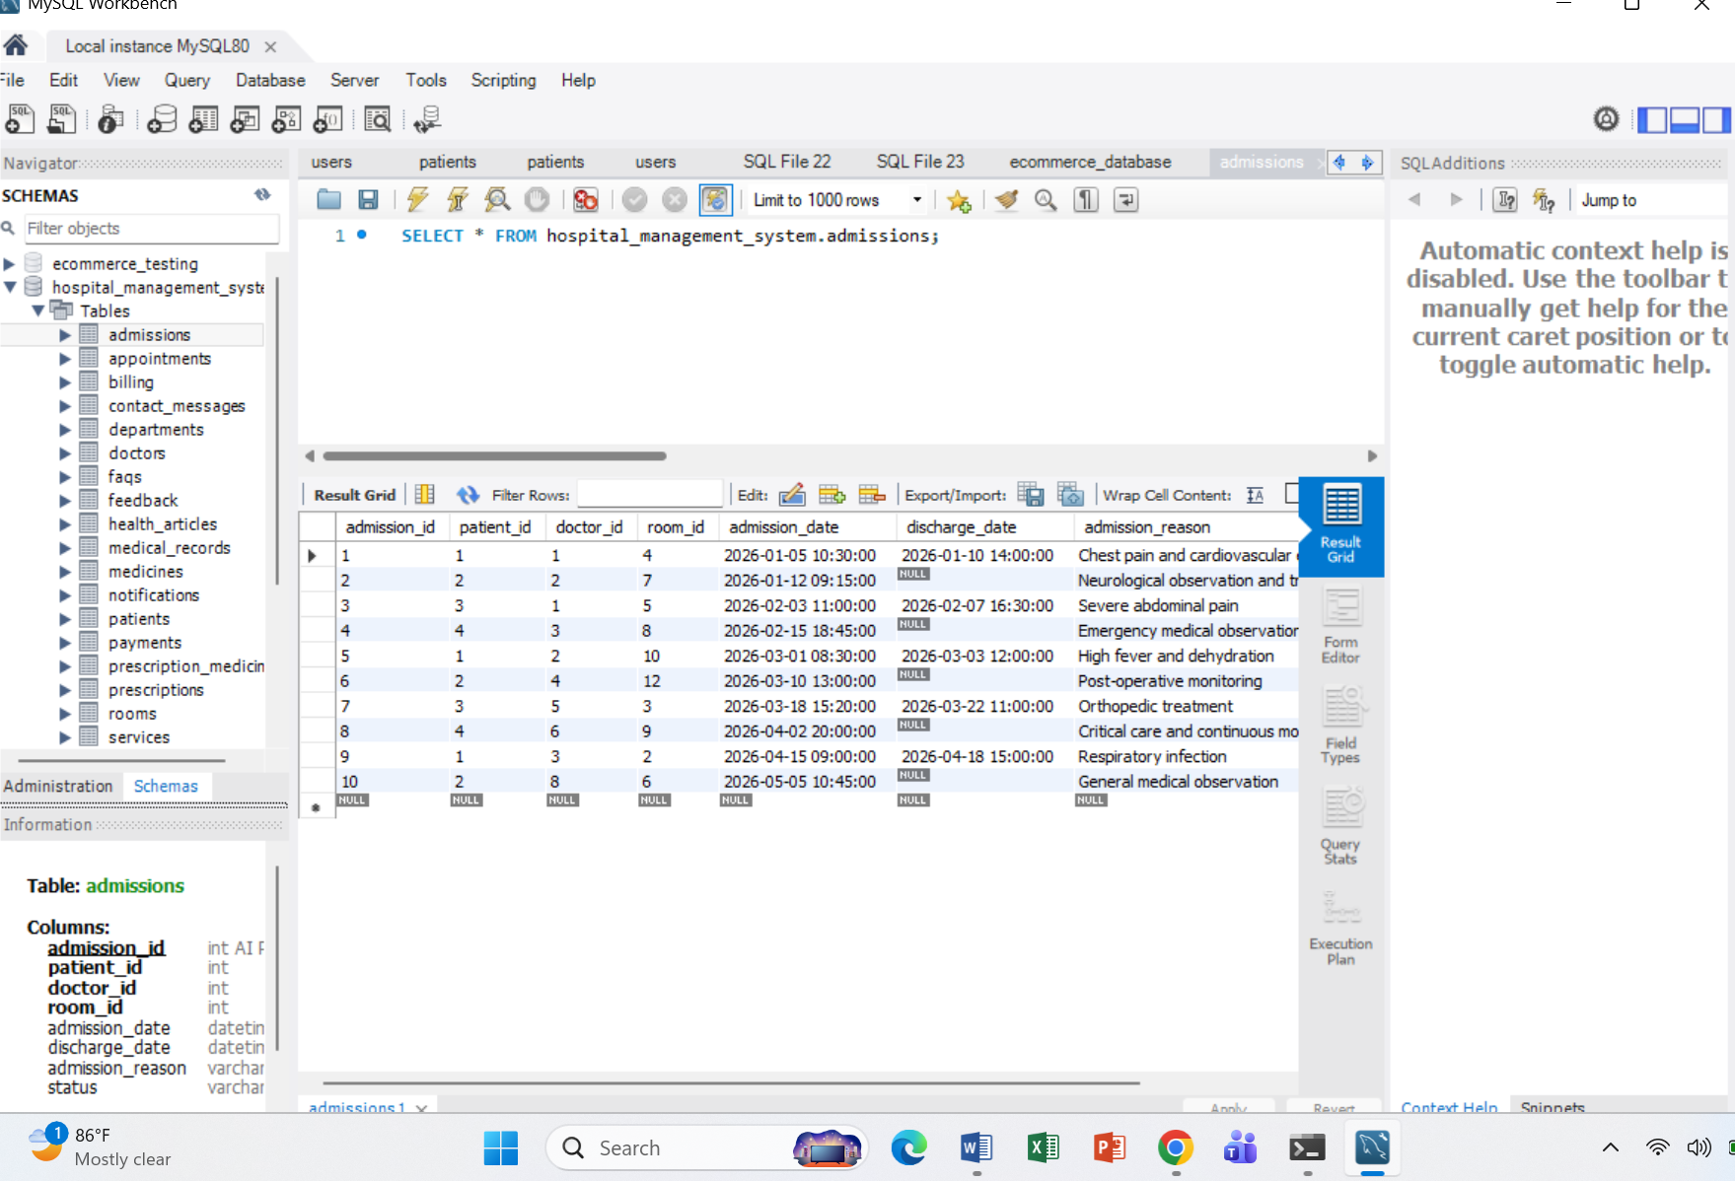
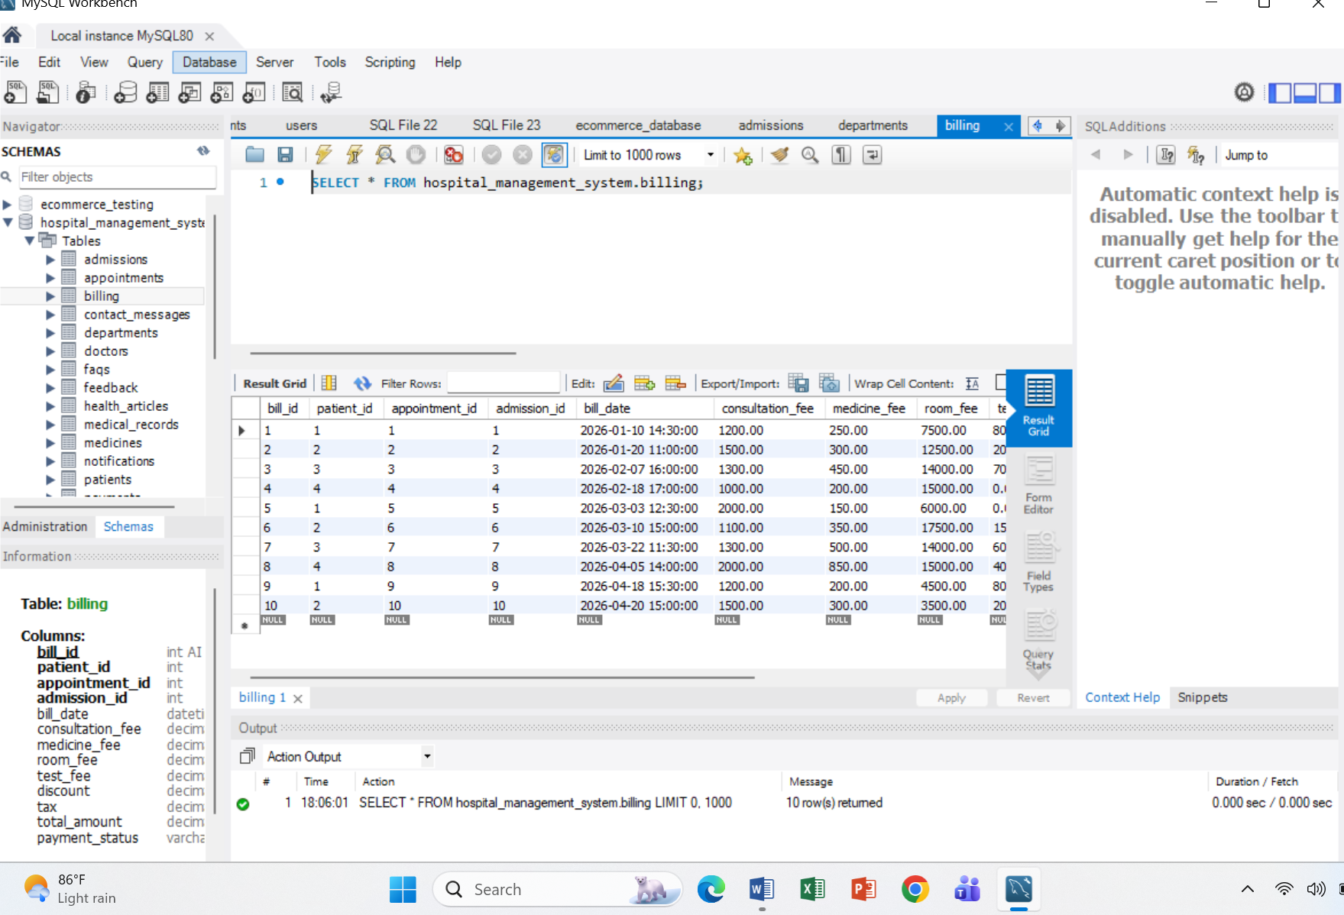
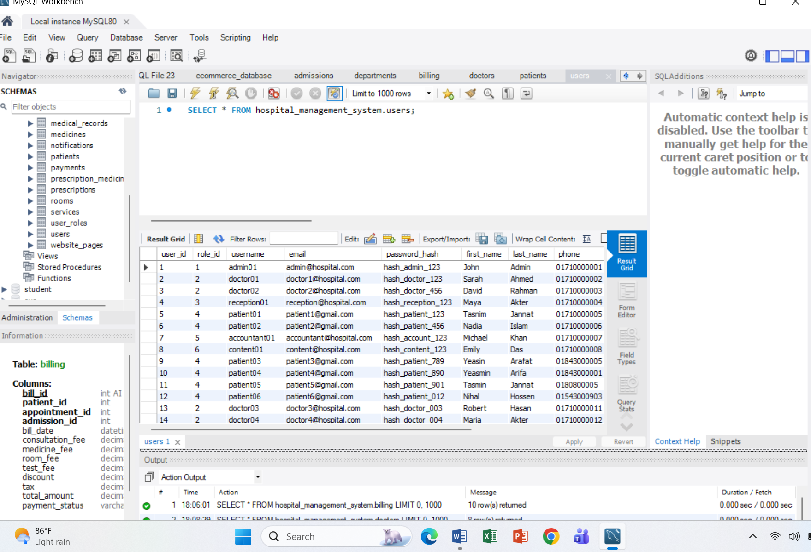

Step 04:
ER Diagram:
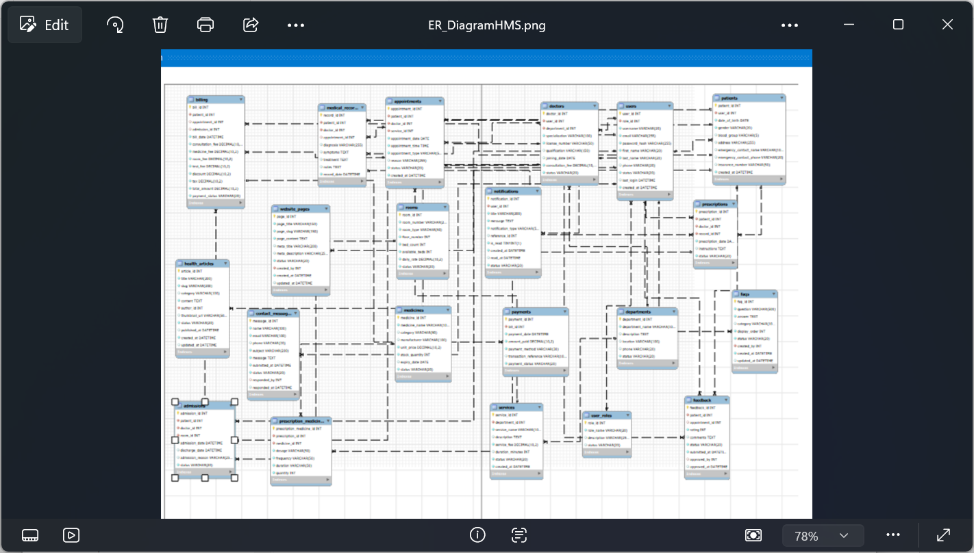

Step 05:
Database Verification:
CRUD Testing:
Create / INSERT:
INSERT INTO departments
(department_name, description, location, phone)
VALUES
('ENT', 'Ear, Nose and Throat Department', '2nd Floor', '01700000001');
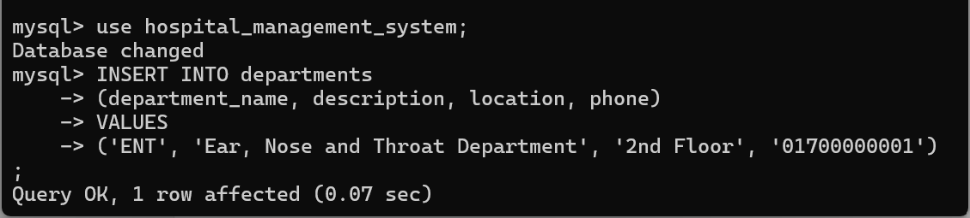

Read / SELECT
SELECT *FROM departments;
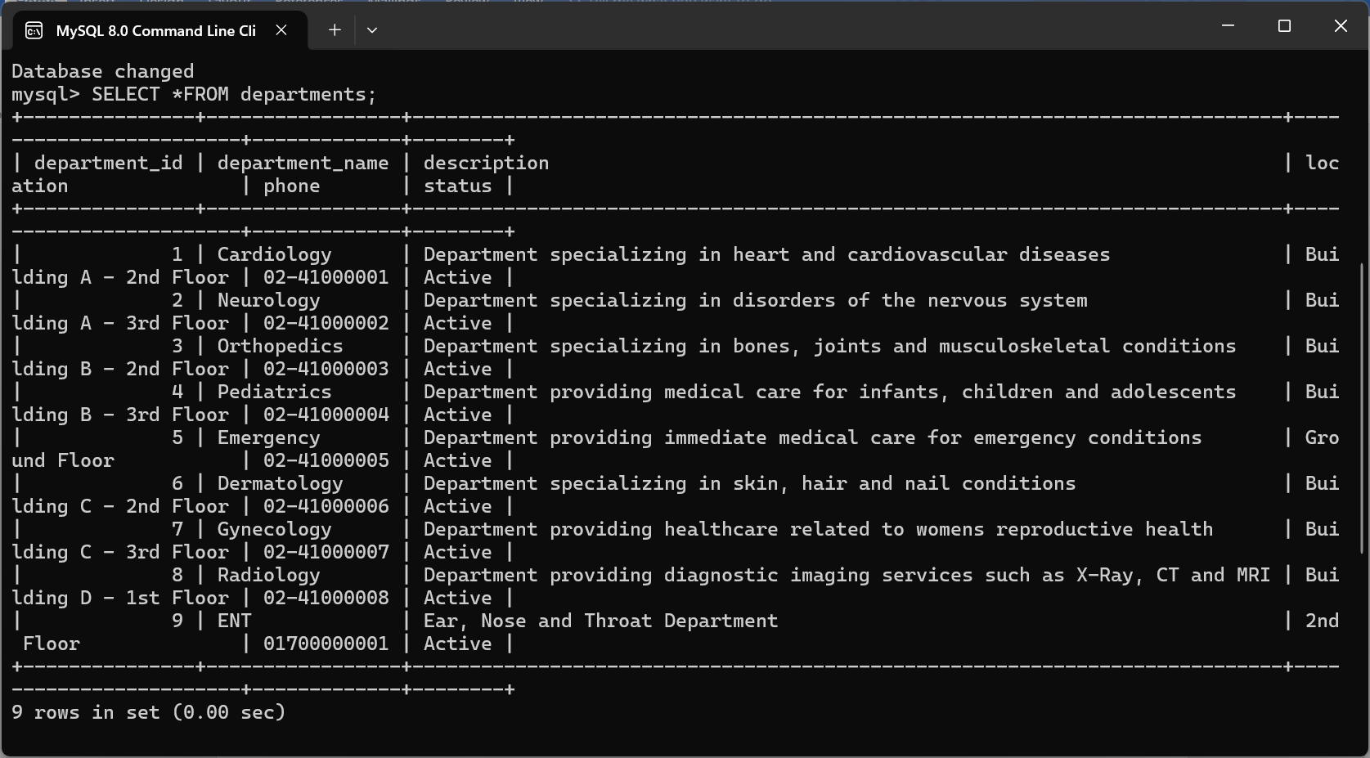
SELECT *FROM departments where department_id = 2;
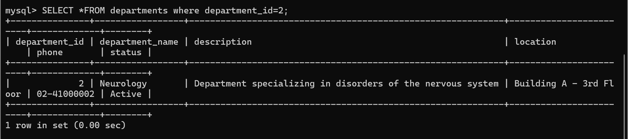
Update:
UPDATE departments SET phone = '01800000001' WHERE department_id = 9;
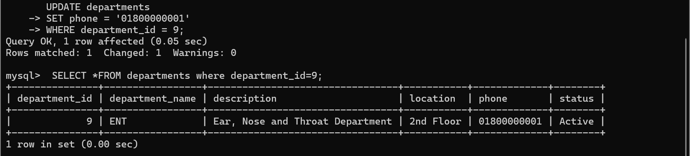
Delete:
DELETE FROM departments WHERE department_id = 9;
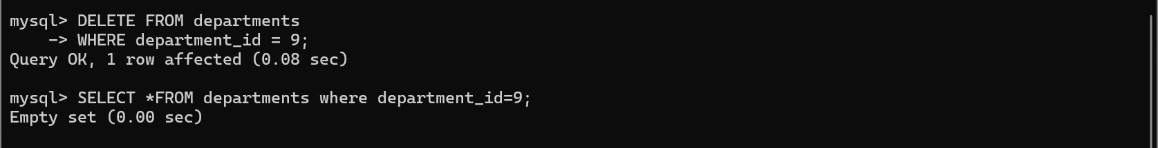
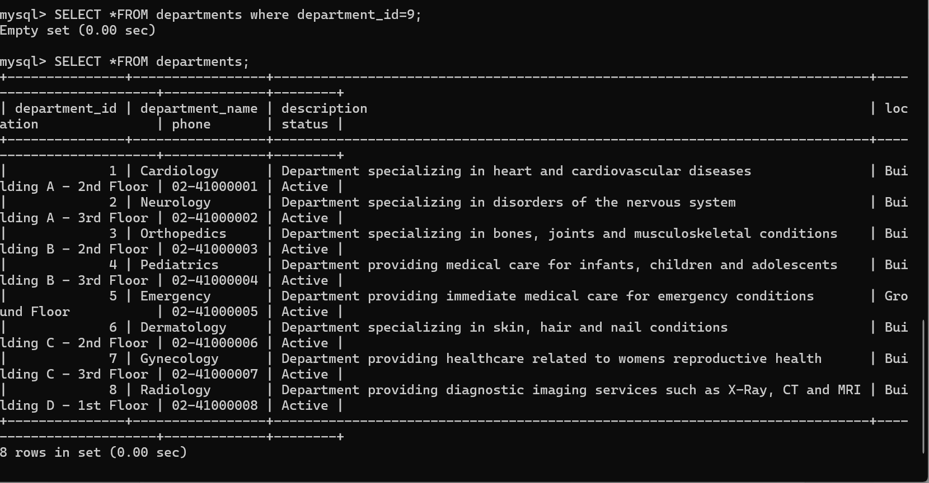
Primary Key Testing:
Check whether IDs are unique:
SELECT patient_id, COUNT(*) AS total FROM patients GROUP BY patient_id HAVING COUNT(*) > 1;
Expected: 0 rows.
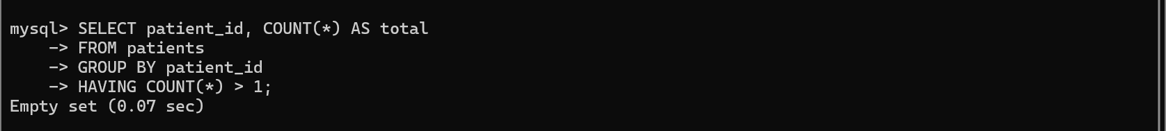
Check NULL primary keys:
SELECT *FROM patients WHERE patient_id IS NULL;
Expected: 0 rows.
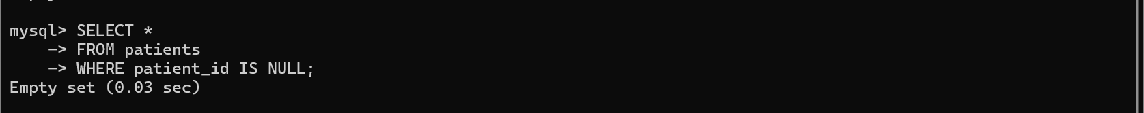
Foreign Key Testing:
Find patients whose user_id does not exist:
SELECT p.* FROM patients p LEFT JOIN users u ON p.user_id = u.user_id WHERE u.user_id IS NULL;
Expected: 0 rows.
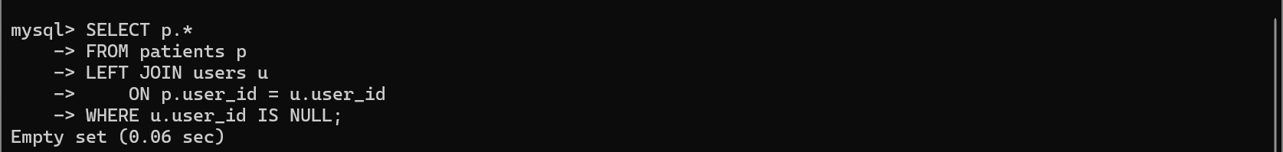
Check doctors:
SELECT d.* FROM doctors d LEFT JOIN users u ON d.user_id = u.user_id WHERE u.user_id IS NULL;
Expected: 0 rows.
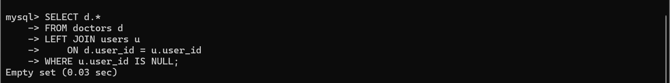
Check appointments:
SELECT a.* FROM appointments a LEFT JOIN patients p ON a.patient_id = p.patient_id LEFT JOIN doctors d ON a.doctor_id = d.doctor_id LEFT JOIN services s ON a.service_id = s.service_id WHERE p.patient_id IS NULL OR d.doctor_id IS NULL OR s.service_id IS NULL;
Expected: 0 rows.
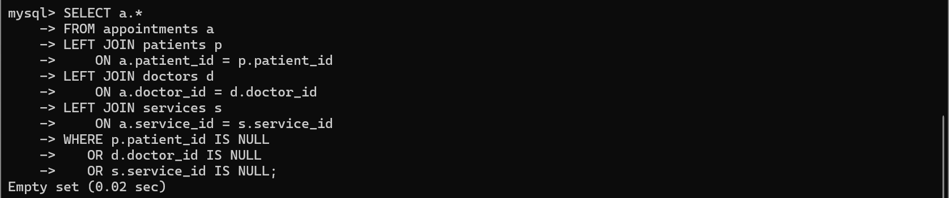
Duplicate Data Testing:
Duplicate patient insurance numbers:
SELECT insurance_number, COUNT(*) AS total FROM patients WHERE insurance_number IS NOT NULL GROUP BY insurance_number HAVING COUNT(*) > 1;
Duplicate doctor license numbers:
SELECT license_number, COUNT(*) AS total FROM doctors GROUP BY license_number HAVING COUNT(*) > 1;
Duplicate usernames:
SELECT username, COUNT(*) AS total FROM users GROUP BY username HAVING COUNT(*) > 1;
Expected: 0 rows for all.
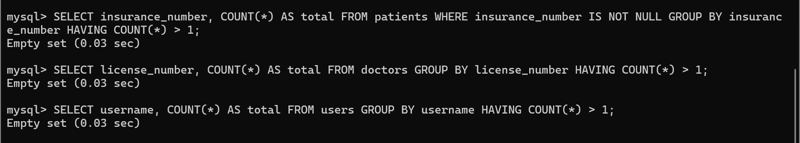
NOT NULL Testing:
Find patients with missing required fields:
SELECT * FROM patients WHERE user_id IS NULL OR date_of_birth IS NULL OR gender IS NULL;
Doctors:
SELECT * FROM doctors WHERE user_id IS NULL OR department_id IS NULL OR specialization IS NULL OR license_number IS NULL;
Expected: 0 rows for all .
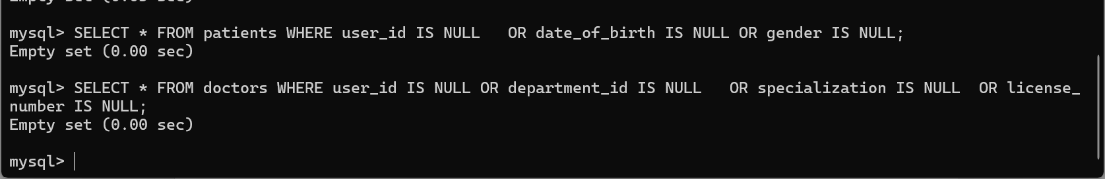
CHECK Constraint Testing:
Invalid patient gender:
SELECT * FROM patients WHERE gender NOT IN ('Male', 'Female', 'Other');
Invalid blood group:
SELECT * FROM patients WHERE blood_group IS NOT NULL AND blood_group NOT IN ('A+', 'A-', 'B+', 'B-', 'AB+', 'AB-', 'O+', 'O-');
Invalid doctor fee:
SELECT * FROM doctors WHERE consultation_fee < 0;
Invalid medicine stock:
SELECT * FROM medicines WHERE stock_quantity < 0;
Expected: 0 rows for all .
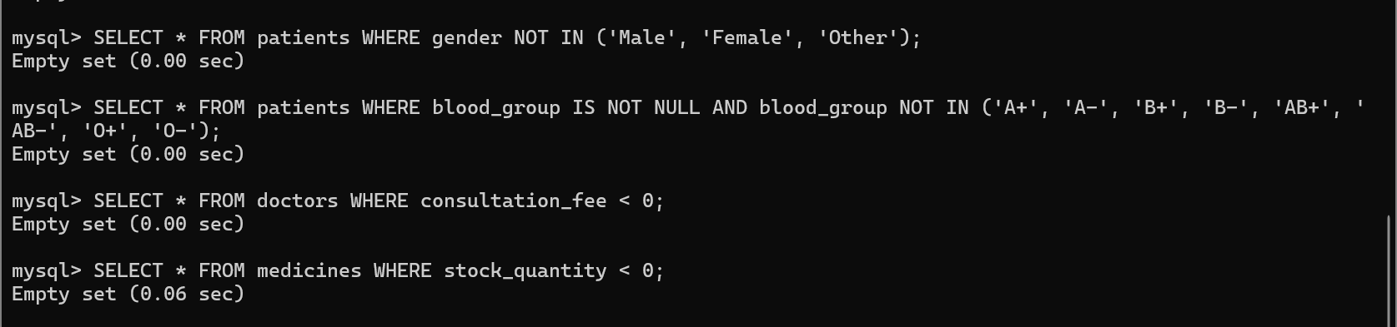
Appointment Testing:
Check invalid appointment status:
SELECT * FROM appointments WHERE status NOT IN ('Scheduled', 'Confirmed', 'Completed', 'Cancelled', 'No Show');
Check invalid appointment type:
SELECT * FROM appointments WHERE appointment_type NOT IN ('In-Person', 'Online', 'Emergency', 'Follow-Up');
Check appointments with invalid patient/doctor relationship:
SELECT a.appointment_id, a.patient_id, a.doctor_id, a.service_id
FROM appointments a LEFT JOIN patients p ON a.patient_id = p.patient_id
LEFT JOIN doctors d ON a.doctor_id = d.doctor_id
LEFT JOIN services s ON a.service_id = s.service_id
WHERE p.patient_id IS NULL OR d.doctor_id IS NULL OR s.service_id IS NULL;
Expected: 0 rows for all .
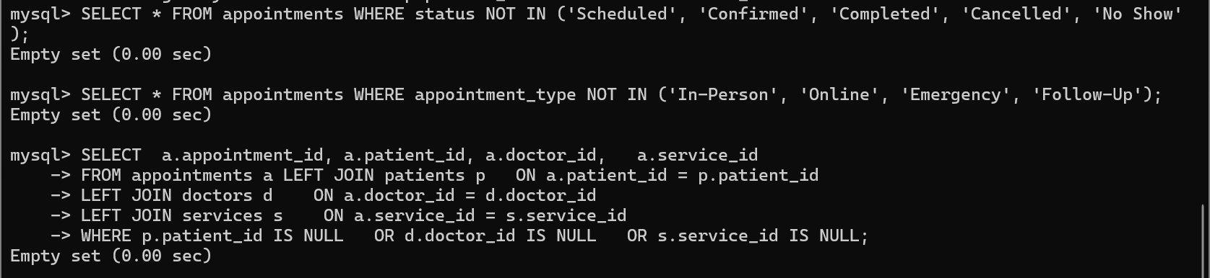

Doctor & Department JOIN Testing:
SELECT
d.doctor_id,
u.first_name,
u.last_name,
d.specialization,
dep.department_name
FROM doctors d
JOIN users u
ON d.user_id = u.user_id
JOIN departments dep
ON d.department_id = dep.department_id
ORDER BY d.doctor_id;

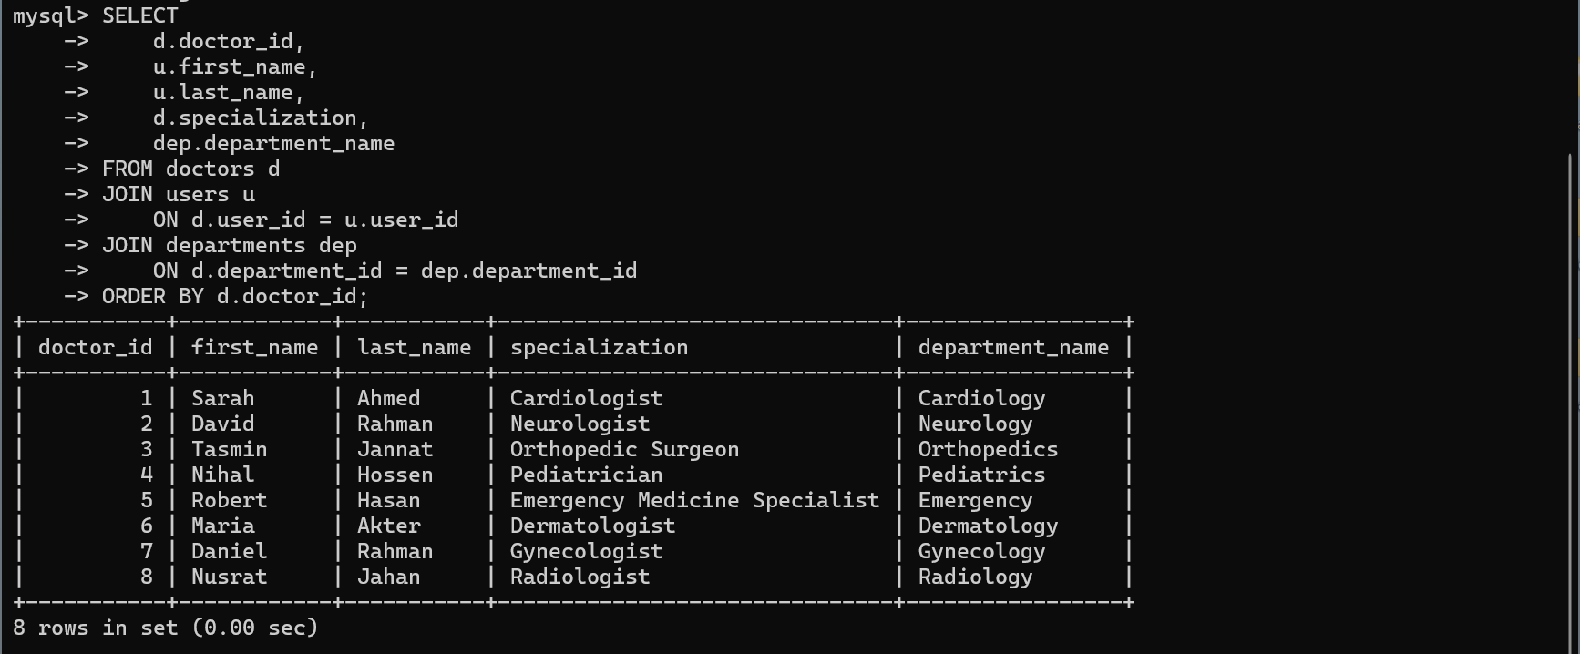

Patient & Appointment JOIN Testing:
SELECT
a.appointment_id,
CONCAT(u.first_name, ' ', u.last_name) AS patient_name,
d.specialization,
s.service_name,
a.appointment_date,
a.appointment_time,
a.status
FROM appointments a
JOIN patients p
ON a.patient_id = p.patient_id
JOIN users u
ON p.user_id = u.user_id
JOIN doctors d
ON a.doctor_id = d.doctor_id
JOIN services s
ON a.service_id = s.service_id
ORDER BY a.appointment_date;

Medical Record JOIN Testing:
SELECT
mr.record_id,
CONCAT(pu.first_name, ' ', pu.last_name) AS patient_name,
CONCAT(du.first_name, ' ', du.last_name) AS doctor_name,
mr.diagnosis,
mr.treatment,
mr.record_date
FROM medical_records mr
JOIN patients p
ON mr.patient_id = p.patient_id
JOIN users pu
ON p.user_id = pu.user_id
JOIN doctors d
ON mr.doctor_id = d.doctor_id
JOIN users du
ON d.user_id = du.user_id
ORDER BY mr.record_date;

Prescription Testing:
SELECT
pr.prescription_id,
pr.patient_id,
pr.doctor_id,
pr.record_id,
pr.status
FROM prescriptions pr
LEFT JOIN patients p
ON pr.patient_id = p.patient_id
LEFT JOIN doctors d
ON pr.doctor_id = d.doctor_id
LEFT JOIN medical_records mr
ON pr.record_id = mr.record_id
WHERE p.patient_id IS NULL
OR d.doctor_id IS NULL
OR mr.record_id IS NULL;
Expected: 0 rows.
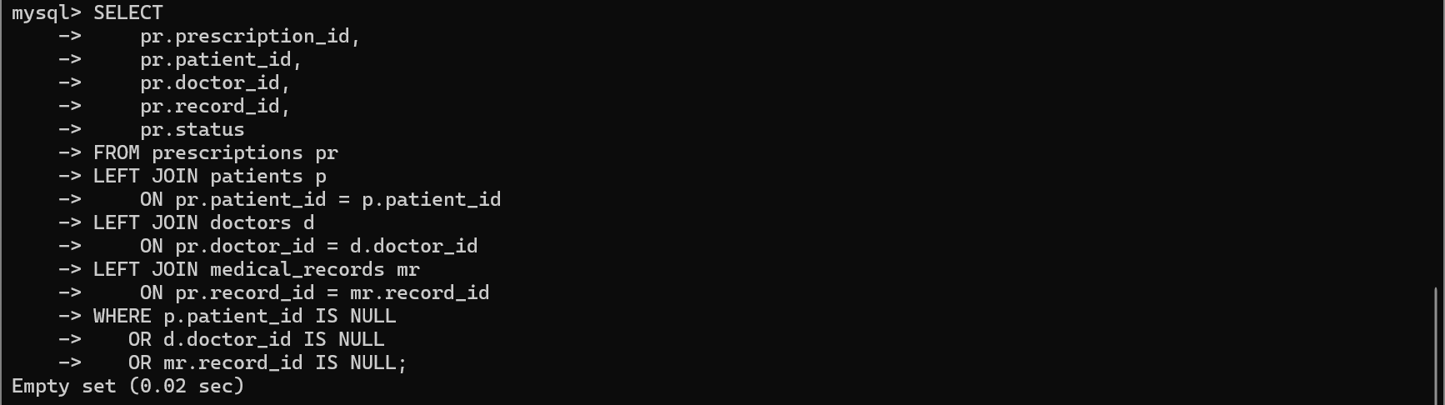

Prescription + Medicine JOIN:
SELECT
pm.prescription_medicine_id,
pm.prescription_id,
m.medicine_name,
pm.dosage,
pm.frequency,
pm.duration,
pm.quantity
FROM prescription_medicines pm
JOIN medicines m
ON pm.medicine_id = m.medicine_id
ORDER BY pm.prescription_id;

Medicine Stock Testing:
Find medicines that are out of stock:
SELECT *
FROM medicines
WHERE stock_quantity = 0;
Find medicines marked Available but having zero stock:
SELECT *
FROM medicines
WHERE status = 'Available'
AND stock_quantity = 0;
Expected: ideally 0 rows.
Find expired medicines:
SELECT *
FROM medicines
WHERE expiry_date < CURDATE();

Room & Bed Testing:
Check invalid bed counts:
SELECT *
FROM rooms
WHERE bed_count < 0
OR available_beds < 0
OR available_beds > bed_count;
Expected: 0 rows.
Check room status:
SELECT *
FROM rooms
WHERE status NOT IN
('Available', 'Occupied', 'Maintenance', 'Inactive');

Admission Testing:
Check invalid admissions:
SELECT *
FROM admissions
WHERE discharge_date IS NOT NULL
AND discharge_date < admission_date;
Expected: 0 rows.
Check invalid patient/doctor/room references:
SELECT a.*
FROM admissions a
LEFT JOIN patients p
ON a.patient_id = p.patient_id
LEFT JOIN doctors d
ON a.doctor_id = d.doctor_id
LEFT JOIN rooms r
ON a.room_id = r.room_id
WHERE p.patient_id IS NULL
OR d.doctor_id IS NULL
OR r.room_id IS NULL;

Billing Total Validation:
This is one of the most important tests in project.
SELECT
bill_id,
consultation_fee,
medicine_fee,
room_fee,
test_fee,
tax,
discount,
total_amount,
(
consultation_fee +
medicine_fee +
room_fee +
test_fee +
tax -
discount
) AS calculated_total
FROM billing;
Find incorrect totals:
SELECT *
FROM billing
WHERE total_amount <>
(consultation_fee +
medicine_fee +
room_fee +
test_fee +
tax -
discount);
Expected: 0 rows.

Payment Validation:
Find payments greater than the bill amount:
SELECT
p.payment_id,
p.bill_id,
p.amount_paid,
b.total_amount
FROM payments p
JOIN billing b
ON p.bill_id = b.bill_id
WHERE p.amount_paid > b.total_amount;
Expected: 0 rows, unless overpayment is intentionally allowed.

Payment Status Testing:
SELECT *
FROM payments
WHERE payment_status NOT IN
('Pending', 'Completed', 'Failed', 'Refunded');
Check invalid payment methods:
SELECT *
FROM payments
WHERE payment_method NOT IN
('Cash', 'Card', 'Bank Transfer', 'Mobile Banking', 'Insurance');

Billing & Payment JOIN:
SELECT
b.bill_id,
b.patient_id,
b.total_amount AS bill_amount,
COALESCE(SUM(
CASE
WHEN p.payment_status = 'Completed'
THEN p.amount_paid
ELSE 0
END
), 0) AS total_paid
FROM billing b
LEFT JOIN payments p
ON b.bill_id = p.bill_id
GROUP BY
b.bill_id,
b.patient_id,
b.total_amount
ORDER BY b.bill_id;

GROUP BY Testing:

Patients by gender
SELECT
gender,
COUNT(*) AS total_patients
FROM patients
GROUP BY gender;

Doctors by department
SELECT
dep.department_name,
COUNT(d.doctor_id) AS total_doctors
FROM departments dep
LEFT JOIN doctors d
ON dep.department_id = d.department_id
GROUP BY dep.department_id, dep.department_name;

Appointments by status
SELECT
status,
COUNT(*) AS total_appointments
FROM appointments
GROUP BY status;

HAVING Testing:
Departments having more than one doctor:
SELECT
dep.department_name,
COUNT(d.doctor_id) AS total_doctors
FROM departments dep
JOIN doctors d
ON dep.department_id = d.department_id
GROUP BY dep.department_id, dep.department_name
HAVING COUNT(d.doctor_id) > 1;
Services with average fee greater than 500:
SELECT
department_id,
AVG(service_fee) AS average_fee
FROM services
GROUP BY department_id
HAVING AVG(service_fee) > 500;

Aggregate Function Testing:

Total patients
SELECT COUNT(*) AS total_patients FROM patients;
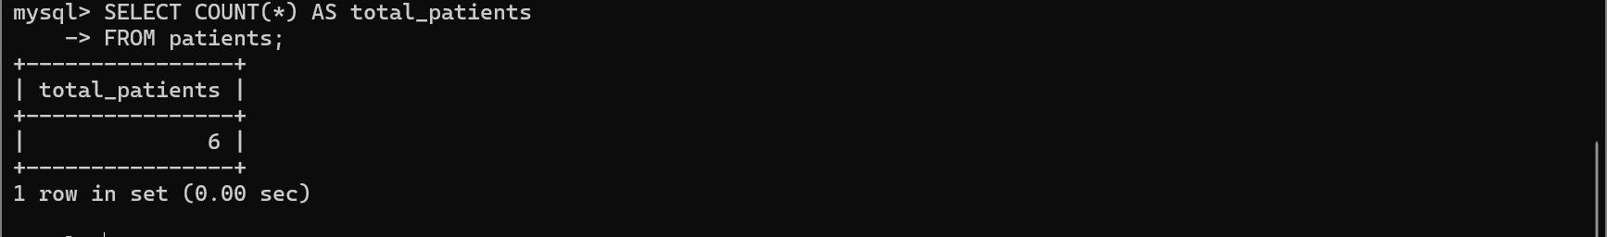

Average consultation fee
SELECT AVG(consultation_fee) AS average_consultation_fee FROM doctors;
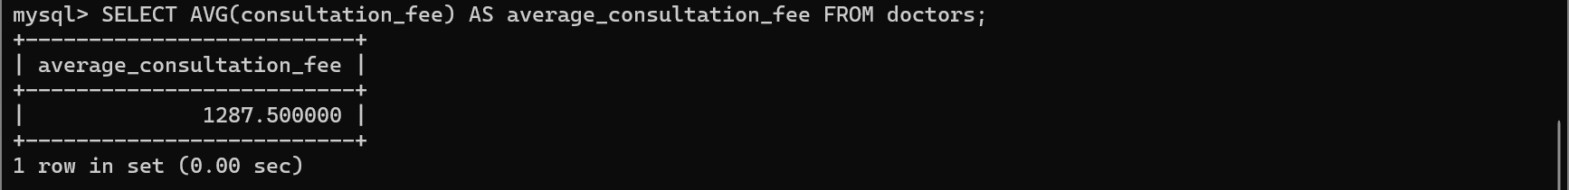

Highest consultation fee
SELECT MAX(consultation_fee) AS highest_fee
FROM doctors;

Lowest consultation fee
SELECT MIN(consultation_fee) AS lowest_fee
FROM doctors;

Total medicine stock
SELECT SUM(stock_quantity) AS total_stock
FROM medicines;

Feedback Testing:
Check invalid ratings:
SELECT *
FROM feedback
WHERE rating < 1
OR rating > 5;
Check approved feedback without approver:
SELECT *
FROM feedback
WHERE status = 'Approved'
AND approved_by IS NULL;
Expected: 0 rows.
Average rating:
SELECT
AVG(rating) AS average_rating
FROM feedback
WHERE status = 'Approved';

Contact Message Testing:
SELECT *
FROM contact_messages
WHERE status NOT IN
('New', 'In Progress', 'Resolved', 'Closed');
Check resolved messages without response information:
SELECT *
FROM contact_messages
WHERE status IN ('Resolved', 'Closed')
AND responded_by IS NULL;

Notification Testing:
Your table has an important read/unread business rule.
SELECT *
FROM notifications
WHERE (is_read = FALSE AND read_at IS NOT NULL)
OR (is_read = TRUE AND read_at IS NULL);
Expected: 0 rows.
Unread notifications:
SELECT
notification_id,
user_id,
title,
notification_type,
created_at
FROM notifications
WHERE is_read = FALSE
AND status = 'Active'
ORDER BY created_at DESC;

Website Page Testing:
Check duplicate slugs:
SELECT page_slug, COUNT(*) AS total
FROM website_pages
GROUP BY page_slug
HAVING COUNT(*) > 1;
Check invalid page status:
SELECT *
FROM website_pages
WHERE status NOT IN
('Draft', 'Published', 'Archived');

Health Article Testing:
SELECT *
FROM health_articles
WHERE status = 'Published'
AND published_at IS NULL;
Expected: 0 rows.
Check duplicate article slugs:
SELECT slug, COUNT(*) AS total
FROM health_articles
GROUP BY slug
HAVING COUNT(*) > 1;

Data Consistency Testing:

Patient user information:
SELECT
p.patient_id,
p.user_id,
u.username,
u.email,
u.first_name,
u.last_name
FROM patients p
JOIN users u
ON p.user_id = u.user_id;
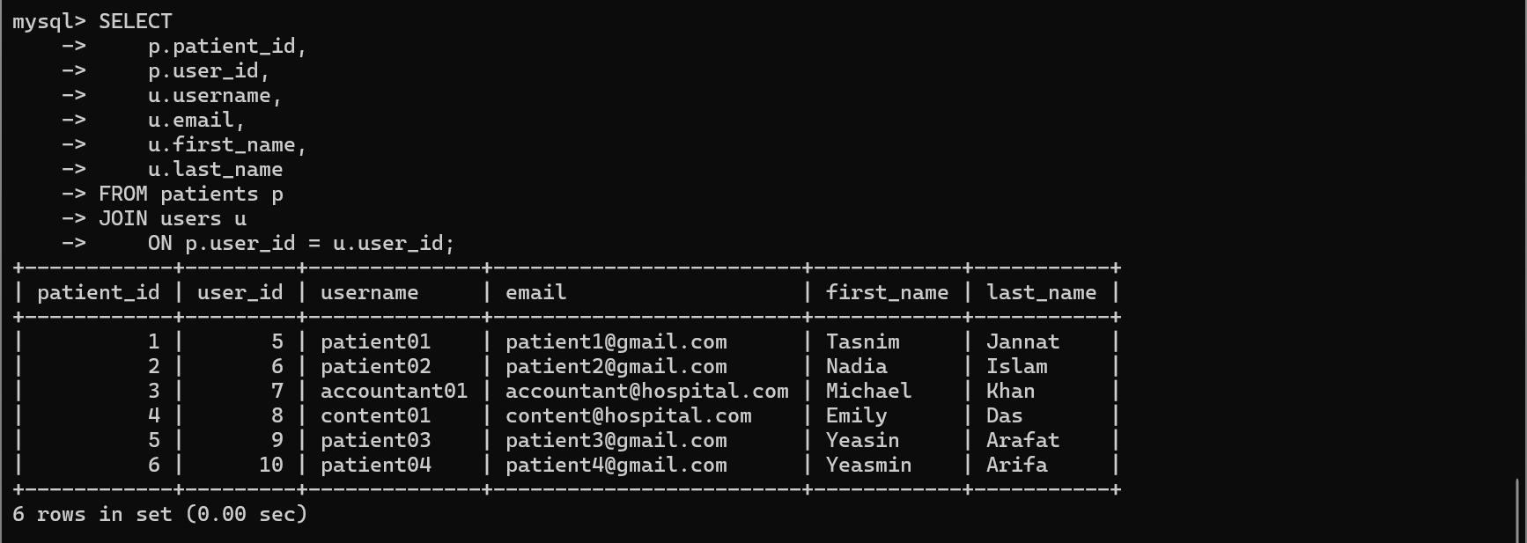

Appointment patient vs medical record patient:
SELECT
mr.record_id,
mr.appointment_id,
mr.patient_id AS record_patient,
a.patient_id AS appointment_patient
FROM medical_records mr
JOIN appointments a
ON mr.appointment_id = a.appointment_id
WHERE mr.patient_id <> a.patient_id;
Expected: 0 rows.

Appointment doctor vs medical record doctor:
SELECT
mr.record_id,
mr.appointment_id,
mr.doctor_id AS record_doctor,
a.doctor_id AS appointment_doctor
FROM medical_records mr
JOIN appointments a
ON mr.appointment_id = a.appointment_id
WHERE mr.doctor_id <> a.doctor_id;
Expected: 0 rows.

Boundary Value Testing:

Doctor fee = 0
SELECT *
FROM doctors
WHERE consultation_fee = 0;

Medicine stock = 0
SELECT *
FROM medicines
WHERE stock_quantity = 0;

Feedback rating minimum
SELECT *
FROM feedback
WHERE rating = 1;

Feedback rating maximum
SELECT *
FROM feedback
WHERE rating = 5;
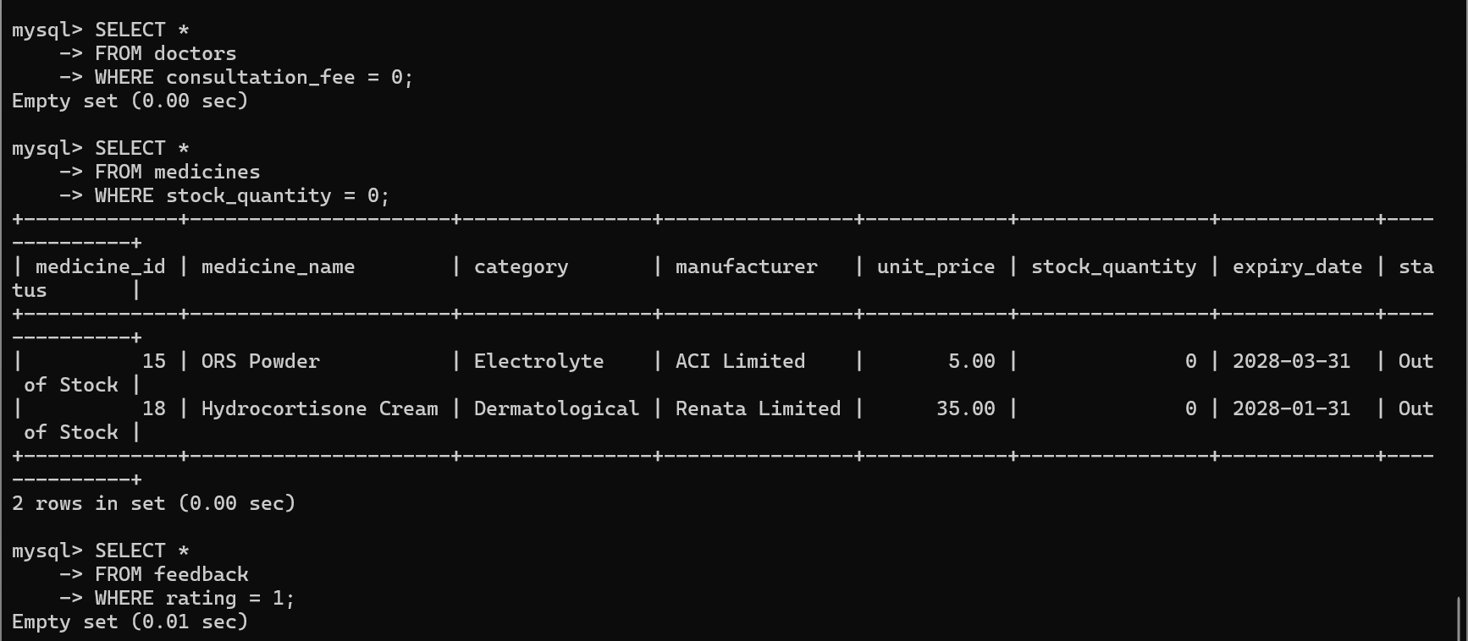

Author: Tasmin Jannat Tahsin

